Kushal Makkar Final JAN-APRIL 2020

1. **Describe your first day at school.**

**Well, a person’s mind stores many good and bad memories he/ she gets from a different period. It depends upon a person which memories they want to share with others or not. Today, I am going to talk about my old school.**

**I had been to three schools in my life. I lived in Bhavnagar when I was three years old. I joined the Sardar Vallabhbhai Patel Institute of Education School there, but after three year, my family and I moved to Surat. I took admission in another school there. I studied from fourth standard to eight there and then moved to its second branch, which was a kilometre away from it.    
I don’t have a clear remembrance of my primary schools, so I would like to talk about my secondary school. My school name is L.P. Savani International School, Surat. It is affiliated with the L.P. Savani Group of schools, Surat.   
The building design was eco-friendly and green. It had four storeys only, and my classroom was on the third floor. It had double-walled construction for heat insulation, high-efficiency air-conditioning systems, solar energy usage, and wastewater recycling and treatment. All the classrooms across the school were enabled with smart boards. They facilitate the learning of the students. The interactive board turned a typical classroom into a fun learning environment. There were all types of labs, such as computer, chemistry, physics, biology, and home science lab, which were equipped with the latest technology. The great thing about the building was that each of its floors was fully equipped with fire extinguishing tools which is very necessary nowadays.   
I was very nervous on the first day because I heard a lot about the school rules and its strictness. Except one of all, my classmates were new. We were entered into the class half an hour before the time, and we felt relaxed when I started to talk with other students. I saw a half school in the morning. So, I decided to see the whole school during the lunch break. After lunch, I was wandering in the school and saw all the rooms and labs. It was true that the school’s rules were very strict, but the teachers were very friendly. I studied from ninth to twelfth there. Also, I made many new friends.**

**1.** **Do you think students should be taken to school by their parents or go by themselves?**  
Children in primary classes should not go to school by themselves. Either the parents should drop them, or they should arrange a van or bus. Children in high school and secondary school can go on their own.

**2. Should children rely on their parents or be independent?**  
Children should rely on their parents till they are studying. Once they complete their studies, they should start earning and become independent.

**3. How can children become more independent?**  
Children can become more independent if parents let them take small decisions on their own when they are very young. If parents allow children some freedom, then children can become independent very soon. It also depends on education and job. If children start earning, they can become independent very soon.

**4. What is the effect if parents interfere with children’s life too much?**  
If parents interfere with children’s lives too much, they either become rebels or withdraw into a shell and become introverts. Their personality is snubbed, and they cannot develop to their full potential.

1. **Describe an aquatic animal.**

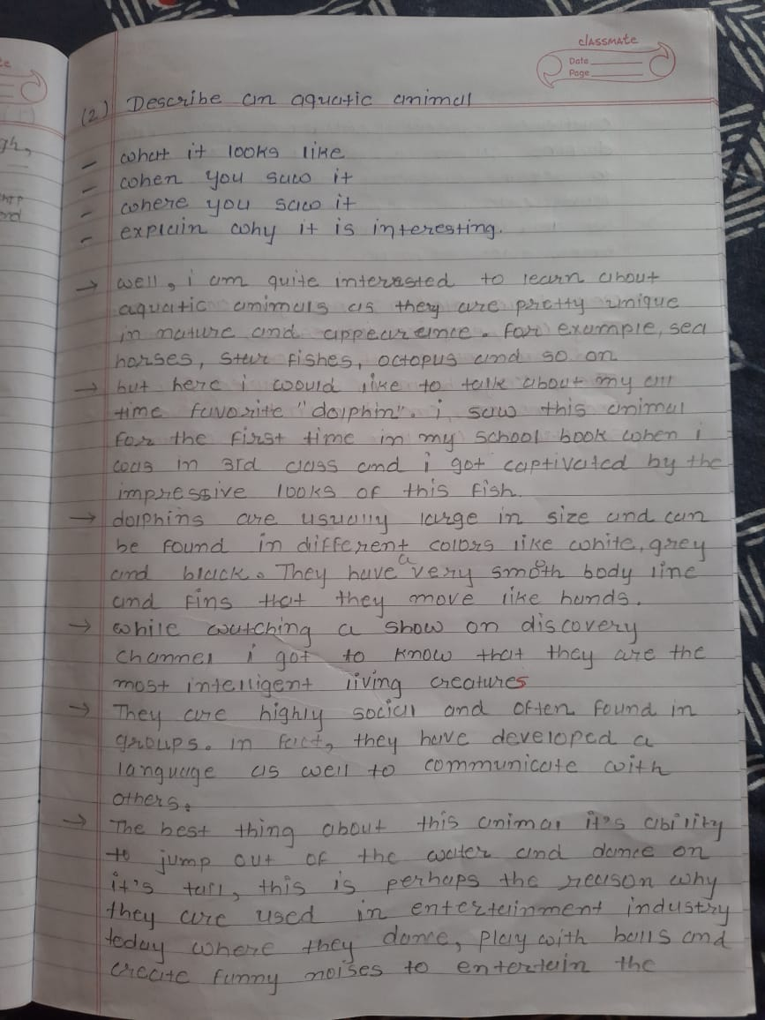

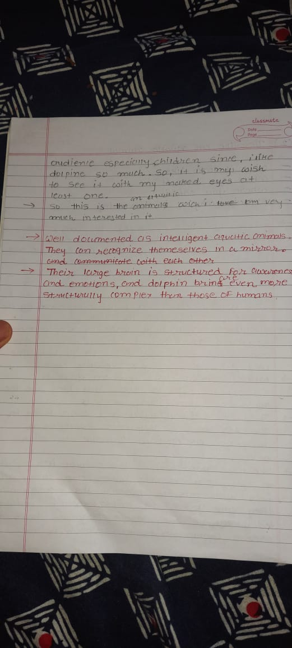

**1. Why do people like to keep pets?**  
Indian people like to keep pets because pets are wonderful companions. Pets, such as dogs give you unconditional love. They also provide security. Some people keep pets in their homes to teach responsibility to their children. Their doctors advise people who suffer from depression to keep pets.

**2. What should we do to protect endangered animals?**  
We should help the governments and NGOs by contributing some funds, however small they may be. We should not do hunting and poaching of animals. We should educate those who are not aware of the importance of animals and the effects their extinction can have on us.

**3. Do you support doing experiments on animals?**  
I do not support experimenting on animals, because nowadays, we can do simulated computer experiments to see the effects of drugs. We should realize that animals are not humans and so any effect on them may not be there on humans. Moreover, animals are sentient beings and should not be disturbed for our selfish motives.

**4. Why do some people refuse to eat animals?**  
Some people refuse to eat animals on religious grounds. Some people do not like the unnecessary killing of animals. They feel that plant sources can also provide them with enough nutrients.

**5. What would happen when some species disappear on earth?**  
It would disturb the ecological chain and would affect us directly or indirectly. We would also lose out on the diversity of nature.

1. **Describe a bag you want to own.**

**I have many kinds of bags like a shoulder bag, messenger bag but my favourite is a backpack and I would like to get a new backpack. There is a mall 40 minutes from my house and there are many shops there that sell these brands such as Puma, Sky bags. Bags are not a must-have item for me. I use a backpack for convenience. However, I am spending some time getting to know more about bags nowadays because I want to buy a new bag.  
I am a student, I am studying IT so I mostly use a backpack because I put heavy stuff inside, such as books, water bottles, and laptops. Backpacks evenly distribute the load on shoulders and hips and don’t put weight on one side of the body like a shoulder bag.**

**As they don’t put much strain on the body, they are easy to carry for hours.**

**Backpacks also allow me to be more organized as they have a lot of separate compartments and smaller pockets.**

**I can keep my keys and wallet in the easily accessible outer pockets and my books and laptop in the main compartment.**

**Backpacks are made from waterproof material can save my belongings from getting wet.**

**Nowadays, all things are easily available on the internet at an affordable price. So, I would like to buy bags through online websites such as Flipkart, Amazon. Online shopping sites offer a considerable discount such as 60% to 80% discount on branded products. That is why I prefer to buy a bag online. In fact, I already started watching bag images and videos online between the range of 800 to 1500. Also, in this technological era we can also get the reviews on social media about different types of backpacks. So, we see the reviews and then after we can go for our favourite bag.**

**I mostly use a backpack regularly, but I have a heavy laptop so I want to buy a big one so that I can be comfortable taking my stuff anywhere anytime.**

**1. Why do you think women like to buy bags?**  
Women like to buy bags because they are convenient and safely carry their makeup, keys, credit cards, etc. Also, women consider bags a style statement, and it helps them complete their overall look. Some women like to buy the latest in trend bags and coordinate their bags with their outfits.

**2. Is the backpack practical in life?**  
Yes, backpacks allow you to be comfortable and hands-free. They don’t put much strain on the body and can be easily carried for hours.

**3. Why are some people willing to buy expensive bags?**  
Some people are willing to buy expensive bags because they are made from good materials and last longer. Some people buy expensive designer bags because they associate them with status and like to flaunt them in front of friends and relatives.

**4. In the future, what changes will bags have?**  
Bags made from canvas, faux leather (vegan leather) will gain more popularity as more and more people will realize that humanity is harming animals to harvest leather.  
Bags will also become more practical in the future, and convertible bags that go from handbag to backpack to shoulder bag will be more common.

**5. Why do children need to carry a uniform schoolbag?**  
Schools want all students to look the same and thus require similar school bags. Requiring everyone to look uniform leads to better academic performance and enhances student discipline. Children need school bags to keep their books and personal belongings in an organized manner.

1. **Describe your favorite singer.**

**I have a number of favourite singers who always force me to evaluate and re-evaluate their musical works because of their unique, and sometimes, extraordinary musical appeal, but one particular singer, who has always puzzled me with her musical talent, is Neha Kakkar for many years.** **She was born in 1988 in Rishikesh, Uttarakhand in a poor family. During the early days, her father, Rishikesh used to sell Samosa outside a college for a living while her mother Niti Kakkar was a homemaker. She had a struggling career and now she is one of the most famous singers in the world.** **She began performing at religious events at the age of four. In 2004, she moved to**[**Mumbai**](https://en.wikipedia.org/wiki/Mumbai)**with her brother, Tony Kakkar and in 2006, at the age of eighteen, participated in the second season of the singing reality show- Indian Idol, in which she was eliminated early.**

**Kakkar's music contains elements of pop, hip hop, and R&B. She admits that she has mostly performed dance numbers which she believes suits her voice the most and complements her energetic vibe, though she expressed her desire to experiment other genres including "soft romantic" songs.**

**Kakkar's work has received praise from several artists. Her co-judge in Indian Idol, Vishal Dadlani praised her for the "impressive progress" from a contestant to judge of the same reality show. Singer Jessi Gill named Kakkar as his favourite playback singer.** **The most important thing about being her fan is her voice. It attracts me. Besides, her devotion to her musical career also requires attention. All such reasons have made her favourite to me. Recently Neha has become the only Indian singer to own the YouTube Diamond Award because of her voice. Her voice is awesome, people in my country loves his voice.**

**She got 15th Mirchi Music award for Mirchi Social Media Icon of the year in 2020.**

**She is the most popular female singer all over the world.**

**Due to her hard work, she is now Judge at the reality show-Indian Idol.**

**1. Do singers play an important role in your country?**  
Yes, singers play an important role in my country. They are an integral part of our culture, and their songs are played in various ceremonies, weddings, and parties.

**2. Do you think celebrities have a lot of income?**  
I think celebrities earn a lot of income, but it is justified. They work hard and entertain us. They also sacrifice their privacy and personal space because of their popularity.

**3. In your country, people prefer to listen to traditional music or foreign music?**  
In my country, the older generation still likes traditional music, but the younger generation is influenced by the western world and prefers to listen to foreign music.

1. **Describe a time you made a promise to someone.**

**The promise means a commitment from someone to do or not do something. As a noun promise means a declaration assuring that one will or will not do something.**

**It is an excellent habit to make some promise and make hard efforts to complete it. A short time ago, I promised my sister that I will help her in her presentation. Well, my sister is doing a job in a company where she works as a web developer, and she lives in Pune. She came back to the home for three months due to the lockdown and continue her work from home.  
I made this promise because Last week her hand got injured because she slipped on the staircase. And, immediately I take her to the doctor for surgery. Doctor said that it’s a fracture in her right hand and she has to take rest for a month. Unfortunately, the next day she had to attend a meeting in which she was going to present a design through the presentation. But her hand did not move properly as well as she was not feeling good. So, she requested me to type her presentation.  
Same-day in the evening, we sat in the study room and we were discussing about presentation. She gave me instructions. And I wrote all the material by following her instructions. It took about 2 hours to prepare the presentation. Next day when she presented her design. Everyone liked her idea and presentation. And everyone was inspired from her work. She took a sigh of relief because she was very tensed about her presentation as her hand was injured.**

**She thanked me and told it was not possible without your help and also, she told me that you will get a gift from myside because I promised her that I will do my best to complete your presentation.**

**1. Generally speaking, do Indian parents make promises to children?**  
Yes, Indian parents often make promises to their children. The promises mainly involve buying new toys or expensive gifts or taking them on vacations if they score good marks in exams or behave well.

**2. Do children also make promises to their parents?**  
Yes, children also make promises to their parents that they will study and not waste their time. They also promise to behave well in the absence of parents.

**3. Do most people fulfil their promises?**  
Unfortunately, many people in India make promises that they know they cannot fulfil or cannot keep. For example, to meet at a particular time.

**4. How do you feel when others break their promises?**  
It annoys me when people break their promises. In fact, in India, promises are frequently made and seldom kept. I believe that we should not make promises that we cannot keep. We should think before we make promises.

1. **Describe an art exhibition that you visited.**

**The art exhibition is a great way to get artists from different areas to exhibit their work together.**

**Not only allow an artist to present their work, but it also allows up-and-coming amateur artists to enter the art world.**

**Last year I went to Rajasthan to attend a conference with my few friends.**

**The meeting was in Jaipur.**

**After the program, we were free, so we decided to visit an art exhibition.**

**Our hotel manager told us about the Gandhi Art Gallery, and he also told us a show was going to start within an hour there.**

**We booked a taxi to the art gallery.**

**Firstly, we read the history of that gallery, that was written on the entrance wall.**

**The Gandhi Art Gallery was born out of a vision to patronize the exceptionally talented local artists. Established in 2000 by Mr. Shankar Gandhi, an avid collector and connoisseur of art, the gallery currently works with over hundreds.**

**Many different types of art, such as painting, drawing, sculpture, were on display.**

**The painting presented different cultures, traditions, and religions of India. Whereas we saw many animals, birds and other decorative sculptures there.**

**I enjoyed the exhibition because we did not need to ask the artist to describe the painting.**

**After all, a small slip pasted on each item, which was explain everything about it.**

**If I get an opportunity to visit it, I will definitely take a visit to art exhibition.**

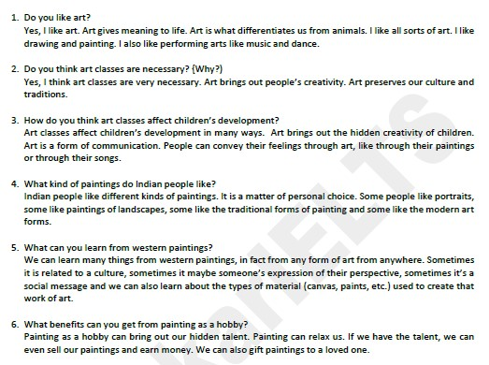

1. **Describe a time when you told your friend an important truth.**

**Well! Usually, I don't keep any secrets from my friends. However, once I had told lie to my friends, and after a few days, I said the truth about it to my best friend Smit. He is not only my friend but also, he is like my big brother and I love him a lot. I always share my goods and bads with him because he can understand my problems very well and he also helps me out to solve that problem. I selected only him to tell that very important truth to him because I trust him.**

**It was about my job offer for which I had to tell lie initially. All my friends were asking about my job interview result whether I got selected or not. Actually, all my friends were expecting a big party if I would get the job offer, but due to some financial reason, I wanted to delay until I get a salary. That's why I said everyone that I didn't get selected, and a few days later I thought I must at least inform my bestie so I spill the beans to him.**

**When I disclosed this lie, he was so happy and in excitement, he started to dance. Then he yelled at me for the lie and when I explained the reason, he said that we could have managed it but this lie takes away other friends' happiness. After a while then disclosed with other friends too.**

**It was very important for me to tell the truth to at least one of my friends because I felt that when they will know from other sources, they would never trust me. From that moment I always tell truth no matter what and will also keep practicing this habit.**

**1. Do you think we should tell truth at all times?**

I don’t think telling the truth at all times is a wise choice. I think if the truth does nothing but hurt a person, I think we should avoid telling the truth.

**2. How do you know when others are telling the truth?**

I think it is easy to tell how others are telling the truth from their facial expressions. For example, people start sweating or avoiding eye contact when they are lying.

However, this might also be sweating due to other reasons and thus it is not easy to determine if people are indeed lying or just physically uncomfortable.

**3. Do you think it is important to win the game or follow the rules?**

I think the victory would feel hollow if people do not follow the rules. It would not feel that the victory was deserved.

So, although the outcome is important, following the rules is even more important.

**4. Sometimes people should tell lies. Do you agree?**

Yes, I believe that if the truth serves no purpose but only hurts other people’s feelings, we should avoid telling the truth.

For example, telling a person just before a party that they don’t look good in the dress would just make them uncomfortable and reduce their confidence.

1. **Describe a skill that you want to teach other people.**

**A skill is an ability to perform an activity in a competent manner.** **I have learned many skills that I can share or teach to others. And I would like to talk about the one which is very important for all people. Yoga is the skill that I would love and want to teach others.**

**During my school days, I had attended Yoga classes from the professional trainer at my school. This has made mandatory in my school, during that time though I wasn't interested in Yoga, gradually when I understand the benefits and feel myself those benefits, I developed a predilection towards Yoga.**

**I have been doing Yoga since I have learned and never skipped for a long time. I believe I still have all the skills required to teach Yoga either individually or in a group. Not only I can teach how to do yoga but its benefits as well so I think I can teach properly. What's more. yeah, I can give them a demonstration while teaching as my body is quite flexible for Yoga.**

**Overall, from my point of view, everyone must do Yoga. It keeps our inner body, outer body, and mentally fit. I believe I will keep executing Yoga forever in my life.**

**1. Should teachers be funny when they teach?**

Yes, I think teachers should employ the use of humour while teaching. It lightens the class atmosphere and improves the relationship between students and teachers.

In other words, students feel comfortable discussing their doubts and problems with the teachers.

However, teachers must learn when to be strict, otherwise, it can impact the discipline in the classroom.

**2. What qualities should teachers have?**

Firstly, I think the most important skill that teachers should have is good communication skills.

They need to understand how to teach in simple words. Secondly, they should be good observers.

They need to be able to pick up the fears and anxieties students have. Only then they can build their confidence. Finally, teaching is about patience. Teachers need to be ready to explain the concepts again and again if their students are facing any difficulty.

**3. Which do you think are more important practical skills or academic skills?**

Practical skills and academic skills have their own importance. I think it depends upon the person’s profession.

If a person wants to be a teacher, a lawyer, or anything in academics, they need to be an expert in academics. However, in other fields like business, communication skills etcetera, are more important.

**4. Which age group is the best age for learning?**

I am a strong believer in the fact that there is no age for learning. We can learn anything at any age. And actually, I believe that we should keep learning new skills as it keeps the mind sharp and active.

1. **Describe a time when you needed to use your imagination.**

**Well, imagination is a wonderful thing. we all use imagination in our day-to-day progress.** **When we read a book or hear a story, we imagine the characters. We also imagine the situation in our minds. In happy times we imagine good things. In sad times, all negative thoughts come in our minds.  But I would like to talk about a situation when I used my imagination days ago, I visited one of my relative’s house which is STONES THROW AWAY from my house. His house is so beautiful and well furnished with modern equipment’s and infrastructure. After spending some time there at my relative’s home, then I come back to my house. I went to my bedroom. But my mind did not give up on the picture of that beautiful house. I was mesmerizing that house. Then I started imagining my new home which may be very beautiful. I took a drawing book, a pencil and a paper and started to draw the infrastructure of my home imagined that my house would be big and the trees would grow around this house my home’s kitchen should be well designed and beautiful. My bedroom would be big rather than all other rooms and it would also be attached with a bedroom. One window and a balcony with trees and plants should be there in my room from which I will see my kitchen garden. I will prefer to live in this home with my family. I was just imagining my future house, then my mother comes and shakes me. My, all imagination had gone waste. One thing which I went to tell you that realty is realty and “distance dreams sound sweet”.**

**1. Do you think adults can have lots of imagination?**  
I don’t think imagination depends upon age. Both children and adults can imagine things. The only thing is that children are not restricted by real-world knowledge in their imagination. So, children can sometimes imagine completely impossible things.

**2. Do you think imagination is necessary for scientists?**  
I think all scientific discoveries are about looking at something from a new or different perspective. So, imagination is certainly important for scientists. Many would have seen an apple fall from a tree before Newton, but he was the first one to relate it to a force.

**3. What kind of jobs need imagination?**  
I think the biggest field with needs imagination is science. Then, another field in which I think is being a fantasy author. A fantasy author basically puts down his imagination on a piece of paper. I think some of the famous fantasy authors like Tolkien or JK Rowling are some of the people with an endless imagination.

**4. What subjects are helpful for people’s imagination?**  
I think literature can be very helpful to develop imagination. I remember reading Alice in Wonderland was so exciting. It was my first time reading a fantasy novel, and I just couldn’t put it down. After reading each chapter, I used to think about what would happen next, and that in turn, was nothing but exercising my imagination.

1. **Describe a special hotel you stayed in.**

**Travelling to interesting places during the holidays certainly is good. But getting to spend a night at a luxury hotel after enjoying a great outdoor during the holidays is even better, and today I would like to talk about the experience of enjoying a few nights at one such hotel.  
  
The hotel, I am talking about, was located at Saputara in the district of “Dang” in Gujarat which was 138km from my hometown. Saputara is a hill station located in Sahyadri or**[**Western Ghats**](https://en.wikipedia.org/wiki/Western_Ghats)**.** **It is a tourist destination. I stayed at the hotel about a few years ago when I was visiting with my family to see the beautiful nature and to see sunset from Sunset point at Saputara. I stayed in a hotel name Saffron Valley. It was a luxury hotel by Saffron groups of hotels, and it had luxury rooms with contemporary and fine dark wood details which were artfully juxtaposed against locally painted images of beautiful nature on the walls. The rooms also included ample seating areas to enjoy the 40” LCD flat-panel televisions along with a fully stocked mini-bar and a coffee pot and also there were many chocolates and cold drinks.**

**And as for the views from the hotel, it was simply outstanding as I could overview the beautiful and ancient rainforest. Not to also mention, of course, the abundant wildlife in the rainforest to play “hide and seek” with us for our amusement.  
  
The hotel was certainly special because of its unique location from where it was just so easy to view the encore and beautiful nature without actually ever stepping out of it. Another great thing about this hotel was that I didn’t exactly pay a “truckload” of money to stay there. Besides, I don’t think that many hotels in this world provide free transportation every day to take its valuable guests to let them visit interesting places around them. Finally, it would be a great injustice if I don’t mention about the exceptional customer service of the hotel staffs who treated us like their own family.**

**1. Do the ratings of people influence their choice?**  
Yes, I think most people look at hotel ratings before making a reservation. I believe it is very difficult to judge how the stay experience would be just by looking at the hotel and room pictures.

**2. How do people reserve rooms?**  
I think people make reservations through internet websites like Goair, Ibibo, Trivago, Oyo etcetera. Some people also make reservations through the telephone.

**3. What influences people’s choice of hotels?**  
I think many factors influence people’s choices. The two main factors are the price of the rooms and the amenities available like air conditioning, TV, locker and so on. Internet ratings and reviews are also a major consideration nowadays.

**4. What’s the difference between hotels in your country and hotels abroad?**  
I don’t think there is any particular difference in hotels. Today, there are hotels from chains like Taj, Hilton, Marriot all over the world. The design may vary depending upon the location, for example, beaches, hillsides etcetera. But as India has all these types of locations, nearly all types of hotels are available here.

1. **Describe a person who wears unusual clothes.**

**Unusual means not habitual/commonly occurring. Nowadays, people mostly judge another person’s personality and behaviour through his dress.**

**Most people used to wear formal and casual clothes that suit their personalities, but I saw some people who wore abnormal clothes or can say unusual garments.**

**Here I am going to talk about my neighbour, who wears unusual clothes.**

**His name is Bharat. He lives with her parents and grandparents.**

**He is 25 years old and doing graduation at a university in my city.**

**He is very good in nature and also, he is very familiar with my family.**

**But his face complexion is not too fair.**

**He wears very unusual clothes such as very bright colours and abnormal dress design. He doesn’t only wear unique clothes but wears unusual footwear also.**

**A few months ago, in December when most people wear woollen clothes, He wore a bright Black colour summer dress with red colour shoes. Everyone thought is he made. Some people also laugh at him, but He did not mind it.**

**I know him since childhood. I think it is not his fault, of wearing different designer clothes because her mother bought clothes for him when He was a child. So, in that way he is habitual to wearing unusual clothes.**

**1. Where do Indians normally buy clothes?**  
Indians buy clothes from a variety of places. I think for fancy clothes people normally shop at malls or branded shops like Zara and for day-to-day or basically casual wear, people go to the street markets. Recently, many people have also started buying clothes online.

**2. The difference between men’s and women’s choices of clothes?**  
I think the first difference is in the shades. Men go for slightly darker and sombre shades like blue, brown, and grey, while women go for brighter colours like pink, yellow, red, etc. Another difference is that most men prioritize comfort over fashion, while it is vice versa in women’s case.

**3. Do clothes affect people’s mood?**  
Yes, certainly. When people feel they look good in something, they feel more confident, which makes them more social and talkative. The comfort level also matters. If people feel they are uncomfortable in something, it also affects their mood negatively.

**4. What do people consider when buying clothes?**  
I think people consider many factors while buying clothes. Some of the main factors are cost, colour, brand, comfort, uniqueness, etc. Personally, I prioritize brand and comfort over other factors.

1. **Describe a time when you had to wait in a long line.**

**Everyone does not like to be in a long queue because it frustrates people and takes away productivity.**

**I wouldn’t say I want to wait for a long time for a person or thing.**

**Today I will talk about a time when I had to stay in a long line for a train ticket.**

**It happened about two years ago. During summer vacations, my family made a plan to go to Rajasthan.**

**We all were very excited and also packed the necessary things.**

**I went to the airport to book the tickets because the online service was not working.**

**When I reached the airport, I saw 40 people already standing in the queue, and I was on 31 positions. People were pushing each other and I was feeling very suffocated and tired.**

**I saw that the ticket officer was working very slowly and took 15 to 20 minutes for each ticket.**

**I stood for approximately more than two hours because the officer took 30 minutes extra to drink tea.**

**I felt despondent.**

**I was also very hungry and it was summer I was feeling very hot but there was not another option. So, I waited for my turn and I called my parents immediately that I will be late due to the crowd at ticket counter so you have your lunch I will be having my lunch after coming home,**

**I thought management at the airport was quite poor because they had only one ticket counter, if they made two ticket counters, they could easily manage the crowd and save people’s precious time.**

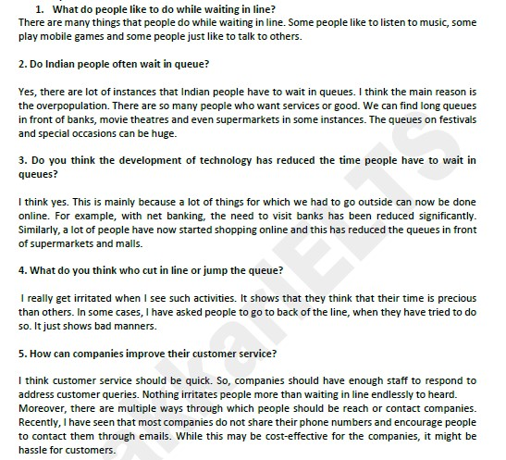

1. **Describe a short trip that you often take but you do not like.**

**Honestly speaking, I love travelling and it doesn’t matter how long the trip is. But there are some areas where I go often, but I don’t like much.**

**Today I will talk about a gym located near my home where I go daily which is STONES THROW AWAY FROM my home, but I do not like it.**

**Two years ago, when I left for my gym from my house my gym is on the first floor so I was on the stairs and suddenly I slipped. I was having much pain on my right leg and I was having my phone in my hands which was broken. After that I have taken medicine from the pharmacy and I went back to the gym workout. I was continuing my exercises with little pain.**

**At that time, I ignored my injury, but afterwards when I get back to my home again, I started suffering through much pain due to the weakness.**

**One of my relative suggested a gym where the instructor teaches and gives exercises simple but effective backbone exercises.**

**I registered my name and gave three month’s fees in advance.**

**I go there daily early in the morning. After a week, I realize I got relieved in back pain. I felt pleased and satisfied.**

**Unfortunately, the gym instructor changed.**

**The old trainer was a very nice natured person and gave instructions very calmly and slowly, but new sir is very strict and rude.**

**He wants everything perfect and on time. He also punished me on getting late.**

**I am helpless because I cannot leave the gym as I already filled fee for three months, and 20 days were still left for three months.**

**1. Do Indian people like to travel abroad?**  
Yes, Indian people like to travel and explore a lot. Indian travellers have been travelling to various countries in Southeast Asia and Europe for many centuries. Now the youngsters have more disposable income, so they make short trips to different countries with their friends.

**2. How much time do you think people should spend on a trip abroad?**  
Well! It depends on the purpose of the trip. Sometimes if it is an excursion, it can be just two-three days or maybe a week, but when you have visited a country to study its culture, you may have to stay there for months. On average, I think two weeks are enough to visit a country.

**3. Who prefers travelling abroad, the young or the old?**  
The young and the old both love to travel abroad, provided there are no health issues for older people, and enough funding for young ones. In my family, my father makes a trip abroad every year. Sometimes he visits to meet my siblings residing there and on other occasions just to see another country. My younger brother also makes frequent trips abroad. So I think we all love to travel abroad regardless of age.

**4. Which is better for knowing more about a country travelling or reading books about it?**  
There is no better learning than travelling. When you travel to a new country, you can soak in the culture, learn a language, try the cuisine, and get a first-hand experience. As compared to this, when you read a book, you are getting a second-hand experience, and you are visualizing or imagining the details narrated by another person or another author.

1. **Describe a place/person/home you like to visit but you don’t want to live there.**

**Being a travel enthusiast, I love to visit different places.**

**But I find the best comfort at my home.**

**Bhavnagar is a place which I like to visit.**

**Bhavnagar is a city in the Bhavnagar district of the Saurashtra region of Gujarat.**

**But I do not have any plan to stay there for a long time.**

**Every year I visit this place to meet my uncle.**

**My uncle lives there with my aunt and cousin.**

**Nature has blessed with scenic beauty.**

**Whenever I visit this place, I feel like I am having the best time of my life.**

**The crowd is less going from one place to another place is an easy task.**

**Since people from all the over the country come here for work, I got a chance to spend my days in a cosmopolitan environment.**

**Every visit offers me something new to learn.**

**The quality time that I have spent in Bhavnagar would always remain etched in my memories.**

**And at Bhavnagar I like to explore many more things such as food or malls.**

**To sum up, I get into a state of flow whenever I visit this place.**

**Despite these advantages, I still cannot settle in Bhavnagar.**

**The primary reason is my unconditional love and support for my parents.**

**Due to old age, my parents feel uncomfortable in the cold temperature of Surat.**

**I have tried umpteen times to convince them, but every time my efforts have gone in vain.**

**Being an obedient son, I consider my parents care as my bounden duty.**

**Although I have decided not to settle in Bhavnagar, I will visit this place every month.**

**1. What type of apartment do most people in your country like to live in?**   
Well, it depends on whether a person is living in the city or the countryside. In small cities, most of the people live in independent houses. Only a few metropolitan cities have high-rise buildings. In the rural areas, people live in houses built out of mud or brick depending upon their financial status. One more interesting fact is that majority of the population in my country lives in rented accommodation.

**2. Do people in your country like to invite others as guests?**  
Yes, people in my country love to invite others as guests. In fact, in our culture, the guests are given the status of Gods. Usually, people like to invite each other for dinners during the holidays. I believe that Indian culture gives a lot more value to relationships than the western world, which is why people here love to develop strong bonds with their neighbours and relatives.

**3. Do people take gifts when they visit each other?**  
Well, I feel that this is a tradition, which is now slowly dying out. Earlier people were very formal about the relationships, and they never went to someone else’s house empty-handed. People used to carry fruits or other items like clothes during their visits, but I see this trend changing now. People are becoming more casual and do not consider it essential to take a gift when visiting someone. The gifting process is now limited to the holiday season or special occasions like birthdays and anniversaries.

**4. What is the difference between the houses in the city centre and the suburbs?**  
There are many differences between the houses located in posh areas of the city and those located in the outskirts. The primary difference is the price, the houses in city centres are generally expensive, whereas those in the suburbs are generally more affordable. Another reason why people move to suburban areas is that because they can build large houses there and these areas are less crowded as compared to city centres. Naturally, there is ample parking space and less traffic congestion in the suburbs.

1. **Describe a perfect job you would like to have in the future.**

**There are many large companies such as Amazon, Reliance Industries, Flipkart, Google which provides good professional jobs.**

**Everyone dreams to work in such an environment which does not promote healthy competition but also includes AMIABLE employees.**

**Even though I always wanted to build my own company, now I have changed my mind and want to gain some relevant experience.**

**I came across a RENOWNED company which LURED me because of its perks. It is Infosys.**

**Yes, I really want to work in Infosys Company. Actually, a few months ago, my friend was looking for a company to work as an intern.**

**Then he ASKED FOR A FAVOR from me. I googled different companies that might be of interest.**

**Then I thought I should google about Infosys itself.**

**When I searched about Infosys on google then I got to know that it has more than almost 2 lakh employees working for it. Moreover, Infosys is India's leading IT sector company.**

**Its PERKS to the employees ASTONISHED me. I have always seen many people who adopt a SEDENTARY LIFESTYLE while working whereas Infosys employees do not face such issues because this company provides different packages.**

**Apart from this, there are many organizations that do not care about employees' well-being and people always have to overwork.**

**However, in Infosys, employees can head over to the on-site massage therapists.**

**It does not only save money but also REFRAIN people from the stress of overwork.**

**I consider it as CHERRY ON THE CAKE. In addition to this, they have a 25%-time policy.**

**This policy goes by the ratio of 75% work and 25% play. These benefits really encouraged me to work hard and achieve my goal of working in the 'Infosys' company.**

**I feel this is a WINWIN SITUATION because happy employees show more PRODUCTIVE in the work.**

**I would consider myself a fortune if I get a chance to work there.**

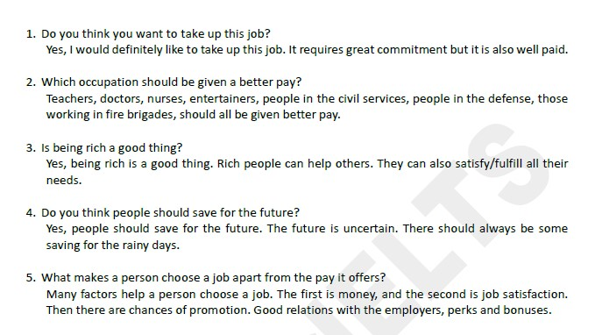

1. **Describe a time when you encouraged someone to do someone to do something that he/she didn’t want to do.**

**I think there are many times that we need to encourage or push others to step outside their comfort zone.**

**Recently, one of my friends, Bhumika and I went to Shimla-Manali. For adventure tour.**

**And I persuaded him to do something that she was really hesitant about trying at first.**

**We were on the visit to North India during the winter vacations.**

**We were locked up during our exam period, and so we both wanted a break.**

**Our plan was mainly sightseeing.**

**However, there we came to know that Rohtang is famous for adventure sports like paragliding, river rafting and cliff diving.**

**I was really excited when I heard about it and really wanted to try them.**

**But my friend is slightly afraid of water.**

**So, she refused to try them.**

**Since my childhood, I have known her, and I knew that she would really regret not doing trying them out later because she is very scared of water.**

**It was also an opportunity for her to get over her fear.**

**So, I encouraged my friend to try it.**

**Initially, she just simply refused.**

**I just kept telling her about all the safety precautions.**

**So, I thought the best way would be to talk to some people who had done them before.**

**Talking to a few of them at the river rafting site, calmed him a bit.**

**They all spoke about how safe it was, and some even called it one of the best experienced of their life.**

**After listening to them, I felt my friend was a little more willing to try.**

**She just needed a little nudge.**

**So, I said I would go first, and if all goes well, she has to follow.**

**Frankly speaking, I wasn’t sure whether she would actually do it.**

**But he did.**

**It was really a great experience.**

**My friend was also really happy and proud of doing it.**

**But when I asked if we could do it again, I got a loud NO.**

**Q1. How could leaders encourage their employees?**  
There are many ways by which leaders and managers can encourage employees like leading through example, incentives and appreciation.  
I think each individual is wired differently. So, while one method may work for some people, it may not work for another person.

**Q2. When should parents encourage their children?**  
I think parents should always encourage their children. However, children need encouragement, especially if they are afraid of failing or trying out something new.  
Parents should tell them that success is secondary and trying is a much bigger achievement.

**Q3. What kind of encouragement should parents give?**  
I think parents can encourage their children in many ways. If children are afraid of embarrassment, parents can do the same thing in front of children first. For example, once in school, one of my friends’ father encouraged him to dance by himself dancing. However, I think the biggest achievement is supporting children when trying something new and telling them that success does not matter as long as they try something.

**Q4. Do you think some people are better at persuading others?**  
Yes, I think some people can motivate others much better. I think it depends upon emotional intelligence. If people can understand other people’s emotions, they can understand better and motivate them.

1. **Describe a decision made by others/someone that you disagreed with.**

**Undoubtedly it is true that decisions play a vital role in our lives. One right decision makes life: on the other hand, one wrong decision can spoil one’s future.**

**The Corona Pandemic has slowed down life considerably.**

**In fact, during the first few days after the lockdown was announced, everyone took it very seriously.**

**Precautions were taken. Rules given by the government had being followed.**

**However, lately, people have become a lot more complacent.**

**As a family, for the past few months, we avoided going out unless it was absolutely necessary.**

**We were also shopping online instead of visiting stores.**

**However, last week my father decided that we should visit the wholesale store Fair Price to buy groceries.**

**He believed that it would be fine if we took precautions like wearing a mask and using sanitizer after every fifteen-twenty minutes.**

**But I was getting a very bad feeling about it.**

**I thought the cases were increasing sharply, and it was not the right time to step out.**

**We could order all those online, although for a slightly higher price.**

**So, I convinced my dad that it was not the right time.**

**As a family for the INITIAL few months, I told him that we might save a few rupees, but is WASN’T worth putting.**

**My mother also supported me but my dad ignored and he was reluctant to agree with us.**

**A few days later, we heard that many people had become infected after visiting Fair Price**

**It was a being labelled a super-spreader by the news media.**

**When we saw the news**

**Lastly, my dad agreed that I was correct and he made a mistake by not considering our worries. So, this was a decision I disagreed.**

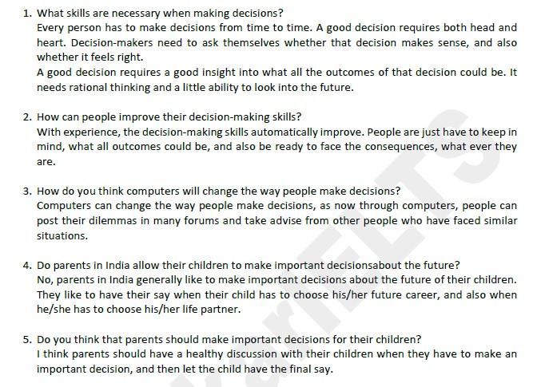

1. **Describe a time when you felt bored.**

Well, there was a time in my school years when I felt bored. Once I was at home for the weekend stay. I used to live in the hostel then and visit home every alternative weekend and spend some time with my friends. This time I got to know that we had a prayer session happening and my mom planned it **precisely** when I was home too.

The prayer meeting was arranged at my house. My father had been **bedridden** for long. Hence, it was both **imperative** and unavoidable for me.

I think I was in the tenth standard. I was 17 years old. This time in life, I was very busy with the school exams study and the responsibilities at the home front as well.

I was home during those days to spend time with mom and dad and especially with my sister because we are very good friends. I never **anticipated** a thick crowd in my house as I entered that day. I had just driven for about eighty kilometres at a stretch. As soon as I got in, I heard praise and worship songs, dad was not in his room, mom lost among those gathered there and my dearest sister was spending her good time with her friends. After a minute, finally, my mom spotted me sitting on my study table with my mobile phone. As we are strong Catholics, she **gestured** me to just sit there peacefully. I was bored to the core of my existence. I was feeling very tired and hungry. Moreover, I cannot use my phone because my mother told me that we should not use our phones in worshipping god. Adding to that, all these people and the **awkwardness**, everything made me uninterested in all that was happening around. I felt extremely **jaded** that day.

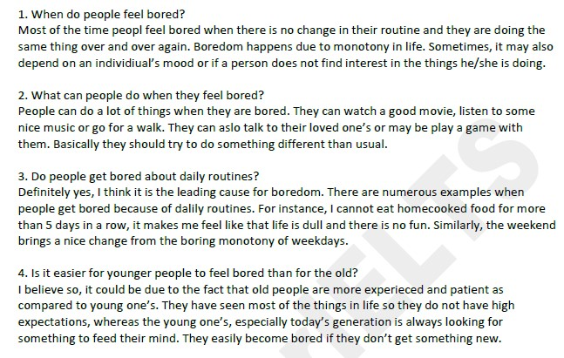

1. **Describe a time when you had to sing a song or a poem in front to public.**

**Being a shy person, I always feel uncomfortable while giving a public performance.**

**When I was in the third standard, I had one such occasion, where I performed in front of a big crowd. It was the day of my school annual function. There were plenty of performances organised by my school authorities such as dancing, drama, comedy shows and many more.**

**There was a competition of reciting a poem in front of the whole school.**

**I never wanted to participate in such an event. But my class teacher and my friends forced me to participate in school annual function.**

**The competition was between the four sections of the third standard.**

**The class teacher chose my classmate Rahul as the performer.**

**He had a melodious voice coupled with good command over the English language.**

**Since everyone had implicit faith in his capabilities, we all classmates had this belief that our section would win the first prize.**

**To our dismay, Rahul had a sore throat that day.**

**He was coughing a lot.**

**Our teacher decided to replace Rahul with our student.**

**My teacher suggested my name.**

**Although I was initially not interested, all my classmates clubbed together convinced me.**

**Being the class monitor, my section’s pride was of utmost importance to me.**

**Therefore, I took the bold step of giving a public performance in front of a large audience.**

**I sang a beautiful poem “Stopping by woods on a snowy evening”. Which was written by Robert Frost.**

**Initially, I was a bit nervous.**

**But once I started, I was in a state of flow.**

**The poem was over in four minutes.**

**The audience gave me a big round of applause. In addition, my classmate and my teacher told me that I had performed very well.**

**I emerged as the winner of that show.**

**My confidence got a significant boost that day.**

**Those four minutes are still etched in my memories**.

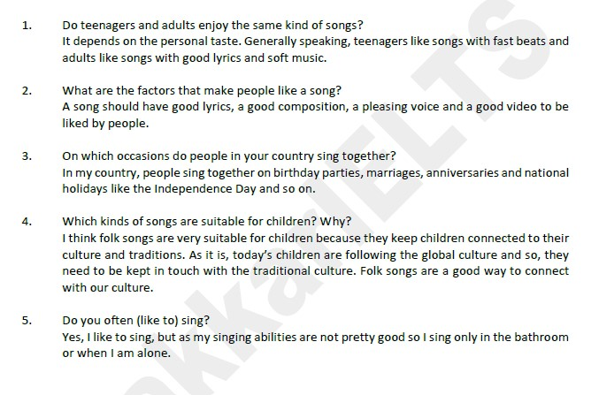

1. **Describe a piece of international news you have just recently heard.**

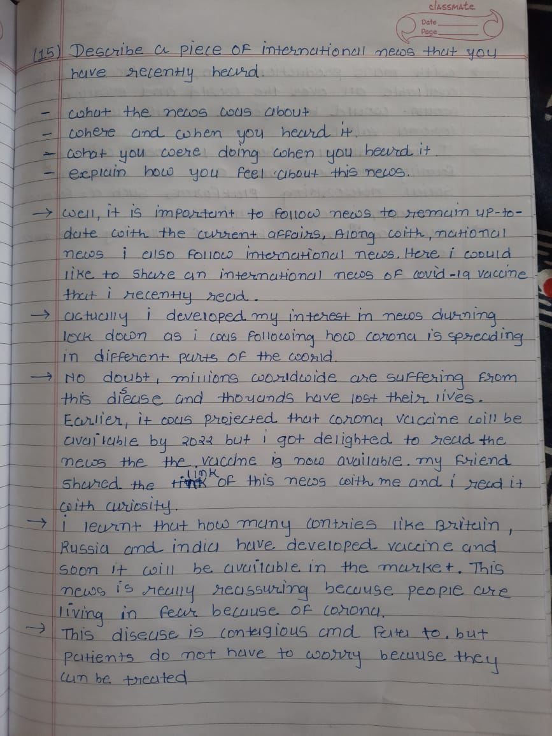

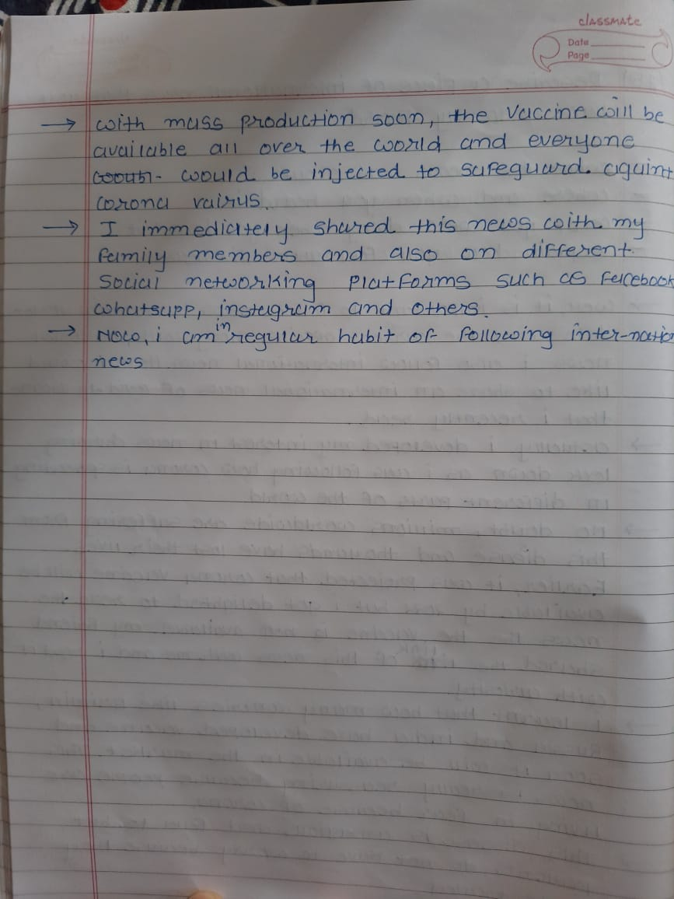

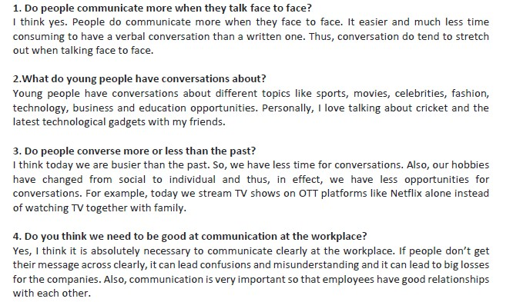

1. **Describe an interesting conversation that you had.**

**A lot of bad things are happening in the Corona Pandemic period. People are free in their houses, but they do lots of conversation on useful and useless topics. I also do a discussion on many issues with my family and friends, but sometimes I get interested to that particular discussion. Here I am going to talk about a conversation in which I was interested. Last week all my cousins and other family members were gathered at my house. We did lots of things together, such as watching movies and playing games.  
Suddenly, my uncle was watching the TV and Kangana Ranaut’s office news was telecasted on it. The news was related to Kanagana Ranaut’s demolition of her office. I saw this news before on social media. Elderly members of my family started discussing it; my cousin also took an interest in it. I also joined the conversation. I saw that The BMC on Tuesday on September 29 issued the notice to Ranaut citing illegal structural violations under section 354A of the Mumbai Municipal Corporation (MMC) Act, 1888. The BMC had sought a reply to the notice within 24 hours, as per the Act, and warned of action. Ranaut, through her lawyer, sought seven days to reply to the notice. However, the BMC on Wednesday initiated the action saying they were not satisfied with the reply. After watching the news on TV, we had dinner and we were discussing about the office of Kanagana Ranaut and especially my dad wants to know that what exactly happened at her office why it was constructed illegally and how did government gave the permission for building it. I was interested in the topic because it was related to the Bollywood actress and it was about illegal things which is popular at the present days. However, I will remember this conversation which I had with my family.**

1. **Describe an unforgettable bike(bicycle) trip.**

**To live fit and healthy, you need to be physically active. Regular physical activity can help protect you from serious diseases such as obesity, heart disease, cancer, mental illness and diabetes. Riding bicycle is one of the best ways to reduce your risk of health problems. Cycling is a healthy, low-impact exercise that can be enjoyed by people of all ages, from young children to older adults. It is also fun, cheap and good for the environment.**

**Today I will talk about a trip on which I went with my friends five years ago. I was lived in a hostel during college/school studies.**

**We were three boys who share the room, and each one had their bicycle, on that we used to go to school because our hostel was located outside, his school/college.**

**During the start of the winter, we decided to go to Mohali for shopping on bicycles. We took permission from our hostel warden for an outing on the weekend.**

**We took all necessary riding gear like gloves, helmets and water bottles.**

**We started our trip early in the morning.**

**There were two villages on the way. After half an hour, we stopped near the first village to rest and had a cup of tea.**

**We started riding again after 15 minutes.**

**After covering one kilometre, one of my friend’s cycle stopped because the cycle chain was broken, luckily it had happened near a workshop.**

**We went there and asked for help.**

**The mechanic took 20 minutes and set the chain. We covered a distance of 18 km within one hour and reached our destination.**

**Even though we were all exhausted because we did not cover the longest distance before that, we enjoyed a lot.**

**We did the shopping, clicked many pictures and had lunch.**

**We came back to the hostel at about 4 PM.**

**1. Do people in your country often travel by bike?**Yes, bicycle is the most popular means of transport in my country, as we are still a developing country. It is difficult for majority of the population to afford expensive transport mediums like cars or motorbikes. In fact, the government in our country is also promoting bicycling as it brings a lot of benefits for the society and our environment.

**2. Which is more convenient, bicycle or a car?**I would say that both of them have their own pros and cons. The car is obviously more convenient when it comes to driving in harsh weather or when you have to reach someplace faster but for shorter distances and especially in congested areas of cities, where the volume of traffic is really high and parking space limited, bicycle is a better choice.

**3. Do you think that children should learn the skills of riding from an early age?**Yes, I believe that children should definitely start learning how to ride from an early age. My parents bought me my first cycle when I was 10 years old and it helped me become more confident about myself. I could go out with my friends on my own and I would say that it also helps to burn that extra energy when we are young.

**4. Do you think cycling is a good way to exercise?**Yes, like I said before it is one of the best ways to exercise and stay fit. Cycling is not just an exercise for the legs rather it is a complete cardiovascular workout. Even doctors also advise people to commute using a bicycle instead of driving in a car. In this way, people, who live a hectic lifestyle can manage a workout in their schedule without doing anything extra.

1. **Describe a computer/phone game you enjoy playing since your childhood.**

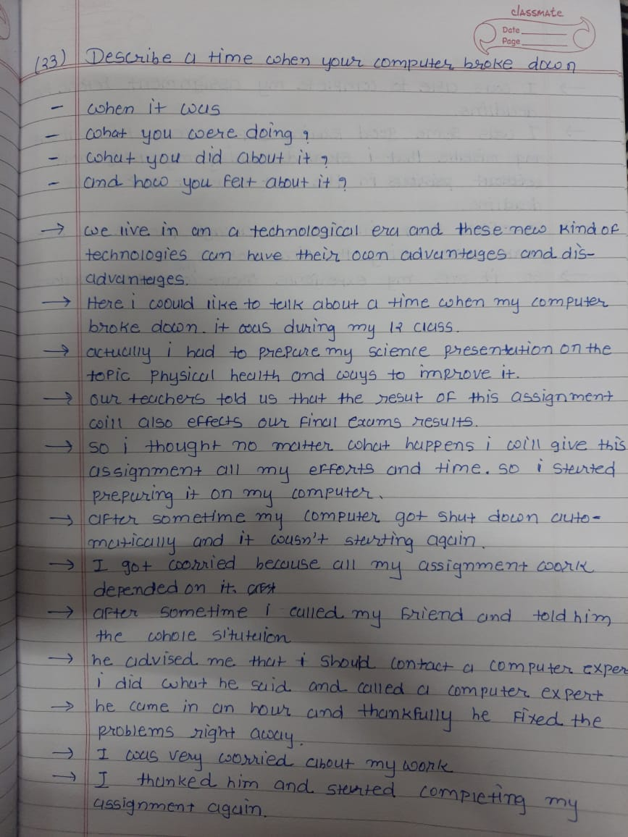

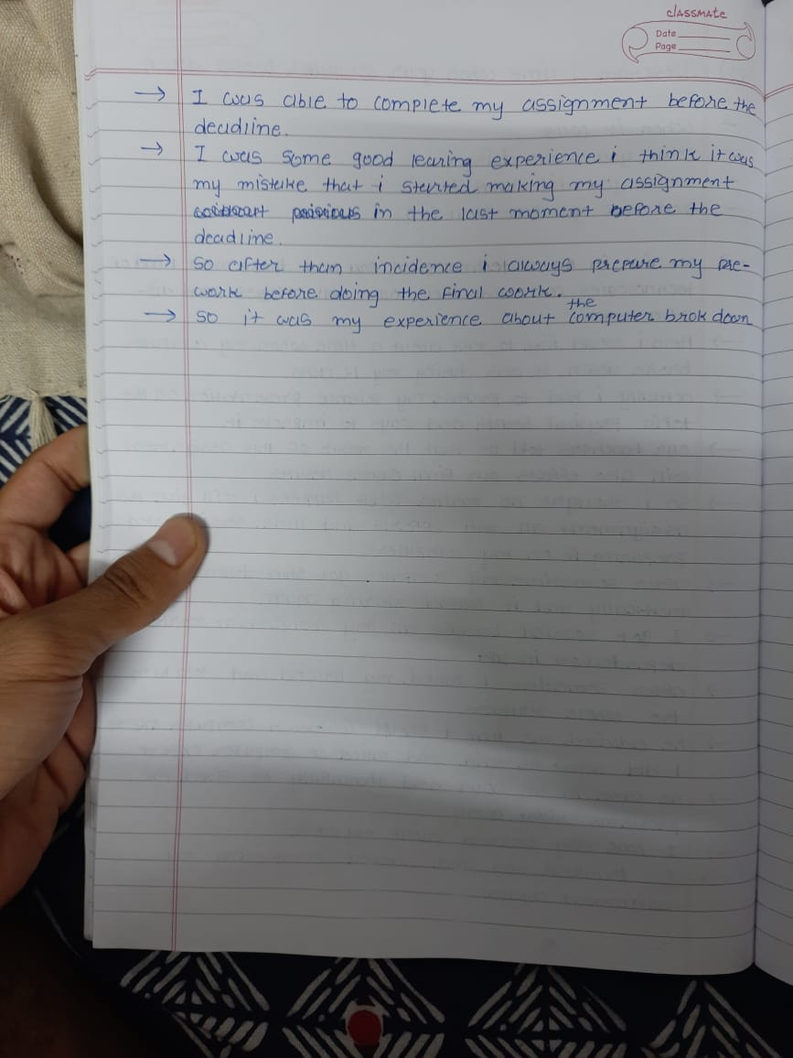

**1.What is the impact of teen addiction to games?**I think there are both positive and negative impacts of video games on teenagers. The positive part is that it helps them to relax and take out the stress from their studies. Also, to some extent, it aids in the development of creative or problem-solving skills. On the contrary, gaming is easily addictive and too much of it can be detrimental for their health and education. Finally, the violent content in some games could promote violent behaviour amongst children.

**2. Should parents or teachers take necessary action to prevent children from playing games?**  
I do not think that parents should stop children from playing computer games, but I believe that it is important for them to supervise the gaming habits of their children. They should monitor the number of hours and type of games being played by the children. If the child is getting addicted to gaming then they should counsel him/her.

**3. What do you think are the benefits of playing games?**  
Like I mentioned before, gaming helps in a lot of ways. First of all, it helps in the development of logical reasoning when children try to solve the challenges in different levels of the game. Secondly, it promotes creativity amongst children as most of the games are based on imaginary concepts and the characters in these games are able to do things that would be otherwise impossible in the real world. So, I think it kind of helps in developing out-of-the-box thinking.

**4. Why games have been popular amongst teenagers in recent years?**  
I think there are multiple reasons why gaming culture has become more popular of late. The biggest reason would definitely be the easy access to free games on mobile devices. Earlier, in order to enjoy gaming, people had to buy expensive gaming consoles and the quality of the games was also not that good. But, nowadays majority of the teenagers have cell phones with them in which one can install multiple, high-end games for free. Also, teenagers can do multiplayer gaming which is much more fun.

1. **Describe a time when you were really close to a wild animal.**

**India is a diverse country. There are many types of animals found in different regions of India. Many different types of animals are present in my country such as pet animals, domestic animals and wild animals.**

**Yes, it is for sure a scary situation, when someone is very close to a wild animal, because it could be dangerous sometimes. Here, I would like to talk about the time when I was very closed to the wild animal and also in a safe manner. I saw a lion, but I was not afraid of it.**

**I have been to the Gir Sanctuary and there was a plethora of wild animals such as Snake, Lion, Leopard, Tiger, and many more. This sanctuary I have been there for a family trip in last December because I was having a short vacation. In addition, Many foreigners visit Gir sanctuary every year to see wild animals.**

**Lion is a carnivore animal, so they mostly eat meat or the flesh of animals. I noticed that the management of Gir national park takes care of all wild animals and gives them proper food from time to time. Lion often attach to the other animals as their food and eat them.**

**As of that day, I had seen Lion only on video or photo, so when I saw them in real I afraid and look at them from far away. As I learned that they are in the cage, I moved further close and saw how immense their body is. If I have a change in the future, I would love to see them again.**

**1.Besides the animal you just spoke about, what other wild animals are there in your country (or, around where you live)?**There are many other wild animals in my country such as tigers, leopards, snakes, camels, deer, giraffes, rhinoceros, lions, hippos, alligators, crocodiles, monkeys, etc.

**2. In general, how do people in your country feel about wild animals?**People have different feelings for wild animals. Some people are scared of them, some worship them, some like them and especially go to the zoos to see them. Some even hunt wild animals for their body parts.

**3. In general, what is the attitude of people in your country towards wild animals?**People have different attitudes towards wild animals. Some people are scared of them, some worship them, some like them and specially go to the zoos to see them. Some even hunt wild animals for their body parts.

**4. Do you like (all) wild animals? (Why? /Why not?)**Yes, I like all wild animals but from afar. I love to see programs about wild animals on the Discovery Channel and the National Geographic Channel and I even enjoy watching them in zoos.

**5. In general, do you think people like wild animals?**Yes, I think they do. The Discovery Channel and the National Geographic Channel are very popular. People even go to zoos to see them. Whenever I went to any zoo, I see a huge rush of people there.

**6. Are there any wild animals that you dislike? Why?**I don’t dislike any wild animal when I see it on TV or in the zoo. But I am sure, I don’t want to be near any wild animal in reality.

**7. What about lions and tigers, do you like them?**After all, they sometimes eat people Normally lions and tigers are happy eating other animals of the wild like the zebras but only when humans provoke them that they eat them.

**8. In your country, are people’s attitudes towards wild animals today the same as people’s attitudes in the past?**Today, the attitude of people towards wild animals is quite different than in the past. Earlier people were afraid of wild animals and used to worship them. They even used to hunt and kill them in great numbers. However, today people are more aware of the importance of animals. They want to conserve them. Some societies such as the SPCA (Society for Prevention of Cruelty to Animals) are taking steps for animal rights.

1. **Describe your favourite weather.**

**Well, I feel lucky to be living in this part of the country where I enjoy all the five different seasons in a year: summer, winter, autumn, spring, and the monsoon.  
However, my favourite season is the winter season; it lasts for just 2 to 3 months. It starts in mid of November and continues till February, and it is my favourite due to so many different reasons. When I was a child, I love winter season very much. I used to wait for this season thinking that when winter will come.  
First of all, generally, the weather remains scorching, and I anxiously wait for this season because the weather gets delightful and cold, and I could enjoy wearing the woollen clothes that are my favourite. Besides, it is also the festival season in my country. Perhaps most of the important festivals like Diwali, Christmas, New Year, Uttrayan all come during this period.    
I always have a lot of fun and enjoyment with my family and friends, at the same time, this season is the wedding season too, so people often organize parties and weddings at this time, so I often get invited to different parties and have much fun, yet another fact is that I could also enjoy traveling during this time.  
Because I get the Christmas holidays and this is the best time to visit the Shimla with my loved ones, which is 1488kms from my home town, and there I could enjoy the snowfall as well and I love to eat Maggie over there in cold weather with my friends. Another reason I like winter is that I enjoy outdoor activities, especially sports, and enjoy my favourite food items that are only available at this time of the year.**

**However, people Face few troubles at this time of the year; for example, there is always a very dense fog that often becomes the reason for road accidents. Moreover, the days are a little dull and gloomy, and people lethargic and find it difficult to get out of their beds.  
But, overall, it is the best part of the year that I like most because I can enjoy a wide range of activities and have a lot of fun and excitement.**

**1.Do you often pay attention to the weather forecast? (Why? /Why not?)**  
Yes, I pay attention to the weather forecast on a regular basis. The reason is I travel a lot and it becomes necessary to know about the weather to be prepared in advance. Also, climate change has made the weather unpredictable. It sometimes rains even in the dry season as such knowing the weather on a day-to-day basis has become a necessity.

**2. How does the weather (or, the weather forecast) affect what activities people do?**  
People prefer to stay indoors on hot sunny days or rainy days and go out for picnics on pleasant days. Also, there are things we like to eat in certain weather – for example, fritters on rainy days, ice creams on warm days, etc. It also affects the clothing patterns. People wear light-coloured loose cotton dresses in summers and dark warm clothes in cold weather.

**3. (Similar to above) How does the weather affect people’s daily lives?**

**4. Why do some people dislike some kinds of weather?**  
I think it’s because the weather can limit people’s activities. If the weather restricts people from enjoying their favourite activity, it can make them dislike that weather. My friend hates rainy days because he likes to play cricket and he can’t do that because of the rain.

**5. Do people wear different clothes in different types of weather (or, different seasons)? (Same as 2)**

**6. Does the weather have an effect on the economy?**  
Yes, the weather affects our economy. For example, due to milder winters, a lot of people from cold northern countries visit us during that time. Thus it promotes tourism. Also, certain weather like hot sunny days boosts the earning of local ice cream vendors. Similarly, winters boost the jackets and sweaters industry.

**7. (Similar but different) (In your country), are there any differences in economic activity in the different seasons?**  
There are differences in certain economic activities. For example, warm clothes’ industry gets a boost in the winter season. Similarly, farming is also dependent upon seasons – certain crops like rice are grown in summers whereas others like wheat in winters.

1. **Describe a part of a city or a town you enjoy spending time in.**

**Well, I live in Surat, which is also known as the Diamond city of Gujarat. It’s One of the major cities of Gujarat. There are numerous places where people can spend their leisure time, like public gardens, gym, community hall and there are many temples which are also situated in my hometown where people go to pay obeisance. Many old age people prefer to go there at temple because they find peace over there and they worship god. Young people mostly prefer to go at gym and spend some time over there by doing some exercises.  
However, my favourite part is a government park which is STONES THROW AWAY from my house, and I regularly visit there. At first, I got to know about this Park when my friend called me to meet there. When I entered into it, I was quite impressed by the appearance as there are many amenities provided, such as a jogging track, gymnasium, fun rides for children, etc. I like to go jogging in this Park in the morning as the atmosphere is entirely and Pleasant, due to which I can easily concentrate on my activities. Moreover, I love to walk on the grass in Summers’s morning as it makes me feel relaxed. Apart from it, whenever I am stressed or feeling down in the dumps, I visit this place since the birds’ chirping, different Colors of flowers, and people enjoying it makes me happy. So, this is a place which I like the most in my town.**

**1. How do public places change in towns or cities?**

Public places change in towns or cities because of the public demand. With the changing times, the new generations want new and modernized facilities.

The administration sometimes makes changes to public places like bus stops with the help of technology, for example, automatic ticket counters.

There are also some NGOs or big companies that provide amenities at public spaces for the disabled or for the old age people so public places do change with time. At the same time, public places in towns and cities also deteriorate with time.

There are many people who spoil the public property they damage the chairs, they break the Gates.

This kind of vandalism is prevalent when the public property is not well guarded

**2. What public places do old people usually go?**

The senior citizens visit public places like parks and Gardens.

With longevity and good medical treatment, the senior citizens nowadays are active so they also enjoy in the markets.

They like to window shop or go to cafes. Drama and theatre is another passion that is Catching up with the older generation here they can enjoy and watch plays and live programs at and economical cost.

**3. Why do young people like to go to public places?**

Young people like to go to public places because they enjoy outdoor activities. At the same time,  
most of the public places are pocket-friendly as compared to expensive dining out or watching a movie.

Another reason for the popularity of public places among the younger generation could be that here they can have small gatherings and also watch other people of the same generation.

**4. Will more people move to cities in the future?**

There is certainly a demographic shift from the villages to the cities and we will see this trend in the future as well.

I think cities offer more amenities in terms of education, healthcare as well as entertainment so people will continue to migrate from the villages to the cities to enjoy all these facilities.

1. **Describe a famous person that you are interested in.**

**I have a number of famous people but here I would like to talk about one particular singer, who has always puzzled me with her musical talent, is Neha Kakkar for many years. She was born in 1988 in Rishikesh, Uttarakhand in a poor family. During the early days, her father, Rishikesh used to sell Samosa outside a college for a living while her mother Niti Kakkar was a homemaker. She had a struggling career and now she is one of the most famous singers in the world.** **She began performing at religious events at the age of four with her sister Sonu Kakkar. In 2004, she moved to**[**Mumbai**](https://en.wikipedia.org/wiki/Mumbai)**with her brother, Tony Kakkar and in 2006, at the age of eighteen, she participated in the second season of the singing reality show- Indian Idol, in which she was eliminated early.**

**Kakkar's music contains elements of pop, hip hop, and R&B. She admits that she has mostly performed dance numbers which she believes suits her voice the most and complements her energetic vibe, though she expressed her desire to experiment other genres including "soft romantic" songs.**

**Kakkar's work has received praise from several artists. Her co-judge in Indian Idol, Vishal Dadlani praised her for the "impressive progress" from a contestant to judge of the same reality show. Singer Jessi Gill named Kakkar as his favourite playback singer.** **The most important thing about being her fan is her voice. It attracts me. Besides, her devotion to her musical career also requires attention. All such reasons have made her favourite to me. Recently Neha has become the only Indian singer to own the YouTube Diamond Award because of her voice. Her voice is awesome, people in my country loves his voice.**

**She got 15th Mirchi Music award for Mirchi Social Media Icon of the year in 2020.**

**She is the most popular female singer all over the world.**

**Due to her hard work, she is now Judge at the reality show-Indian Idol.**

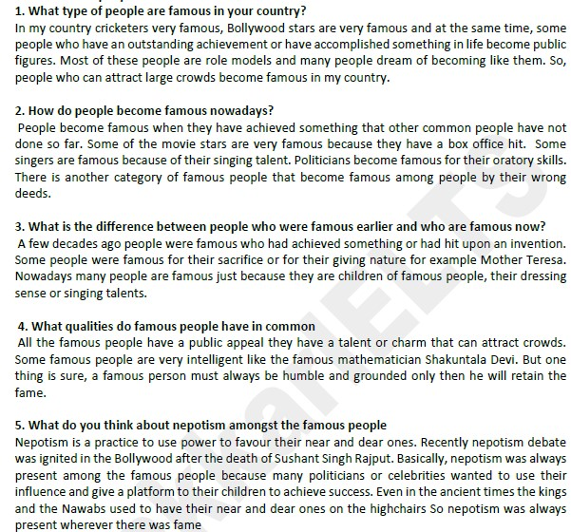

1. **Describe a time when your computer broke down.**

**This happened to me about a month ago. Actually, I have two computers. One laptop is of HP, and the other is a DELL gaming. My Hp laptop is very old because that laptop was used by my sister when she was in 12th science stream, and another laptop is brand new.   
It so happened that my friend Smit had to prepare a project, and he asked me for my laptop for 2-3 days. He was having some issues with his computer and it was taking much load to operate system. Initially, I hesitated to give him because I am very possessive about it. But then I thought of helping him. So, I agreed to give him.   
On the same day when he came to pick up the laptop in the evening, I tried to start it to show him some unique functions on my laptop to make it easier for him to use. To my surprise, my laptop did not start. I was shocked and taken aback. I tried hard to restart it, but it was vain. My Friend was very upset, and first, he thought that I am doing it purposely.**

**I contacted companies’ technician and he said he will solve the problem, but it will take a week. I called my friend, who works at HP service centre in Ahmedabad and he is a hardware engineer, and he said the same.   
I was helpless because I could not do anything to repair it urgently. I was disappointed and confused as to what must have gone wrong with the machine. It was frustrating and irritating, and I also felt worried and anxious about losing important data and pictures. Also, I was having many study materials and programs in my laptop as I am an IT student, I have to keep my files, programs everything in my laptop because it can’t be stored in mobile phone.**

**I gave my laptop for repair at the Service centre and, I offered my friend to use my dell gaming laptop. He was thankful and happy. Later on, my HP laptop got repaired, but it cost me a lot of time, money and energy. I learnt that such high gadgets are handy, but we should not rely on them entirely. Though I did not lose any of my data, I learnt a lesson to take back up in hard disks. After this episode, my laptop broke down twice, but I took regular back up of data. Because it’s the only way to secure and keep my data and it will also help in future too.**

**1. What do people use computers for?**Well, these days the use of computers is limitless, especially in the last year people around the world are using computers as mini offices. We can store our pictures; we can study online with the help of computers and we can even watch movies. So, it depends on people’s personal preferences.

**2. Should students be allowed to use computers at school?**  
I am a strong supporter of the use of computers at school. The main reason why I think so is that they would help them to understand their lessons with illustrations and make learning more interesting. This will also make them fetch the data from anywhere in the world. They can share their knowledge with their teachers instantly by making use of a computer.

**3. What do you think of people who are addicted to computers?**  
Most of the people think that computer addiction is very bad, but my views are not the same. I think if you want to do anything in life you need passion and you need a certain amount of addiction. In the present scenario, we are working with the help of computers. We are locked down in our homes, so we entertain ourselves on computers, we communicate with the near and dear ones with the help of computers. But at the same time, we need to go out exercise and get up after every half an hour or one hour to give rest to eyes and to exercise or body.

**4. Do you think computers make our life simpler or more complex?**Computers make life simpler but these days we are performing many tasks and want all done faster so it seems that they have made our life complex. Imagine in the earlier times if we had to share any news, we had to write a letter to each person and to post it and wait for the reply for a week or so or sometimes even longer. As compared to it, now we have to just type it press a button and share with everyone, so I think they have made our everyday life simpler not complex.

1. **Describe a polite person whom you know.**

**I have met a number of polite persons in my life, and picking just one of them as the politest person is not going to be an easy thing. But I will still go ahead and do that while also hoping at the same time that the others, I know as really polite persons, never hear this conversation! After all, I don’t want the rest to think that I don’t consider them as very polite persons!  
  
Anyway, the person, I want to talk about, was one of my colleagues. Her name was Jayshree Patil. I met meet for the first time when she was introduced to us formally by our Senior Manager at my workplace. She joined IT department.**

**After starting work with Ms Patil, I noticed that she would never talk to me or any of her fellow workers without taking our permissions first. Initially, we found this particular habit of her to be a bit awkward, but as time progressed, we all realized that she was a polite person in nature.  
  
In fact, I had never seen her eating her snacks without asking us to share her food with us first. She used to respect his Senior Manager as some “god” figures. In fact, she was so mild-mannered that even our Managing Director would never reprimand Meet because of work-related reasons. By the way, I enjoyed the company of Jayshree, as long as she was working with us, simply because she would never complain about anything even when she had ample number of reasons to do so.  
  
I think that Jayshree was the politest person, I have ever met because she not only greeted us first but also treated our families just like her own. Besides, the fact that she would never interrupt another person from expressing her or her opinion, even when the person was simply espousing hatred, went to show what kind of polite person Jayshree really was.**

**1. Do you think you are a polite person?**

Yes, I think I’m a polite person. I don’t speak rudely with anyone. I try to help anyone who comes to me for help.

**2. How do you show politeness?**  
I don’t think anyone can show politeness. It just reflects in one’s behavior.

**3. Do you think politeness is important?**  
Yes, politeness is very important. Politeness begets politeness. If we are polite to others, only then we can expect politeness from them.

**4. In your opinion, why is it important to show respect to others?**  
It is important to show respect to others, because it reflects our own nature. If you will respect others only then you will get respect from others. If you will disrespect others, no one will care for you.

**5. Can you give me some other examples of how people show politeness in your country?**  
In my country, people show politeness in many ways. Giving an elderly person your seat in the bus is one method of showing politeness. Standing up when the teacher comes in the class is another way of showing politeness. Stopping your car to let the pedestrian cross the road is also a way of showing politeness. Helping an elderly person cross the road is also a way of showing politeness.

**Cross-Cultural Relations**

**6. Do you think there are any differences between politeness in your country and in the West? OR Do you think politeness is different in different countries and parts of the world?**  
I don’t think politeness has anything to do with the country one comes from. There are polite and impolite people in every country.

**7. How can one evaluate other cultures?**  
One can evaluate other cultures by talking to the people, and sharing views with them.

**8. What do you think might happen if the nations of the whole world showed respect to other nations?**  
If the nations of the whole world showed respect to other nations, then life would become very harmonious and beautiful.

**Politeness in Your Country (in your culture) Teaching Children about Politeness**

**9. How can parents teach their children to be polite? OR How do parents in your country teach their children to be polite?**  
Parents can teach their children to be polite, by setting an example in front of them. If parents are polite, children automatically learn politeness.

**10. Can you think of any examples when young children are not very polite?**  
Children are not polite when they go to the park and don’t offer their swing to the other children when their turn comes. Children are not polite, when they make too much noise and disturb people of the neighbourhood. Children are not polite when they go to somebody’s house and mess things up.

**11. Do you think there is a certain age when children should be expected to be polite?**  
No, I don’t think so. Children should be taught politeness and should learn to be polite from a very young age.

**Public Awareness of Politeness**

**12. Do you think that everyone in society is aware of what is and isn’t polite behaviour?**  
More people are aware of polite and impolite behaviour.

**13. Sometimes there are occasions when the government (or some other authority) wants to remind people about being polite. Can you think of any examples of that?**  
Sometimes, the government has to appeal to the people to be patient and polite. This happens especially on festivals, when people drink and forget what it is right or wrong.

**14. What methods can (or does) the government use to remind people about some aspect of politeness?**  
The government takes the help of media such as TV or radio to aware people.

**Truthfulness and Politeness**

**15. Do you always tell the truth to people?**No, not always! Sometimes a white lie also has to be spoken. For example, recently my six-year-old niece drew a flower, which was not very nice, but I told her that it was very beautiful because I didn’t want to hurt her feelings.

**16. Do you think people are (or should be) honest all the time when they speak to others?**  
Yes, people should be honest when they speak to each other. But sometimes, it is okay to speak a white lie, if the situation demands it.

**17. Do you think telling lies is impolite? OR Are there any times when it might be polite to tell a lie?**No, not always! White lies are not impolite. A doctor might have to tell his patient who is at a late stage of cancer that he will get well very soon, even if it is not the truth. We have to sometimes to use white lies with children to motivate them.

1. **Describe a thing you bought and you are happy about.**

**There are things, which we buy because we need them and there are things, which we buy, not only because we need them, but also because they make us feel happy. Today, I would like to talk about something, which I recently bought and felt really happy about it.  
  
It is a brand-new Dell G7 gaming laptop, which I bought about a few days ago. I bought it at a discounted price because when I visited Dell store it was the day of republic day and there was a sale for republic day, the laptop which I bought came with all the latest tools and technologies, in order to ensure the best services. The device has a very unique and shiny navy-blue colour, and it is about 15 inches wide screen with 4k resolution and it’s the latest i9 generation laptop with NVDIA graphics card. It also came with a beautiful “protector” in order to prevent it from getting damaged. The device has so many features that I am still learning about them. Of course, it was a bit difficult to handle the device initially, as it was a “new” thing for me, but as time passed, I became more and more familiar with its features.**

**And, one feature I remember is in my laptop I got a light under my keyboard or I can say backlit keyboard.**

**Anyway, I bought this laptop, mainly because my old laptop was getting “worn and torn” and as I am an IT student my study is mostly dependent on computers. In fact, I had used my HP Laptop for such a long time that the company technicians sometimes called it an “ancient” machine as they were really struggling to fix it. Finding spare parts to fix my old laptop was also becoming an issue. Besides, I bought this laptop also because it was selling at a very low price. In fact, I paid only 61,000 for it while its regular price was more than 69,000. In addition, I got a free laptop bag and its very big.  
I felt happy about buying this laptop because it helps me a lot like I can carry anywhere anytime while desktop I can’t carry with me. Besides, I felt happy also because I bought it at a very affordable price, unlike my other friends.**

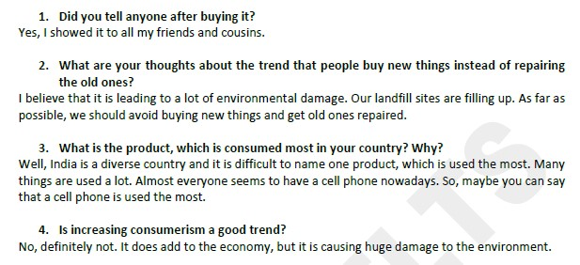

1. **Talk about a time when you gave advice to someone.**

**Well, giving advice is quite common in India. I also gave free advice to my near and dear ones. People give advice even when nobody is asking to give advice. But I personally believe that by giving advice we show our love and care toward others. Here I would like to take about the advice which I gave to my friend Smit.**

**Two months ago, he was in a dilemma to continue his education after bachelors. He is my best friend and whenever he feels low at that time, he calls me to take on opinion. I remembered that day, it was Thursday night when he called me and sound very low. On that time, I asked him about his problem then he told me that he was not satisfied with his further studies because he was not sure about his own studies, he asked me that should I continue my studies or I should start looking for a job. Also, he told me that he wants to start his own business but he confused about how to take  
the first step.**

**He explained his problem to me briefly. I understood his point of view and advise him that if you leave your studies immediately then it means that he will lose his position.  
So, I suggested him that he should continue his further studies after doing masters he can start his own business after taking permission from his parents. Because it’s important to take permission and advice from parents to start a new business. And after 2 years when he completed his masters and he told me that he has started his own business and it was going well and he was earning a lot from his own business.**

**After a few days later, he again called me and thanked me for this advice. Fortunately, I feel extremely glad to see that my advice works in a positive way for him.**

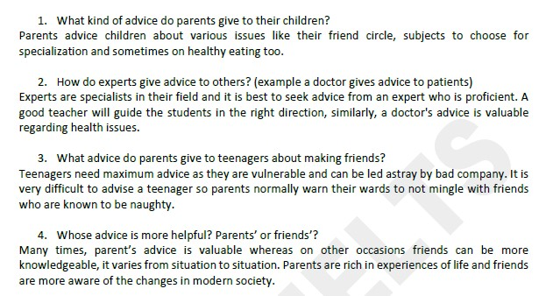

1. **Describe something important that has been kept in your family for a long time.**

**It is a prevalent tradition to preserve things that belong to forefathers as their remembrance and shows respect. Certain items such as furniture, jewellery, vehicles, old brass utensils, and trunks for this purpose here I would talk about a piece of diamond jewellery that our family is keeping.**

**It is a precious diamond ring that my mother received from my grandmother on her 1st anniversary as a gift, which belongs to my great grandmother. It is a ritual in our family that mother-in-law gifts the chain or ring as a part of the legacy to their daughter-in-Law. One day my mother will also forward it to her daughter-in-law. As I said, it is a diamond ring it is quite expensive. It has a unique antique design, and such kind of ring are extremely rare because of hand carving also it takes long time and many hours to form a shape. Along with diamond, there are white pearls and rectangle rubies, which makes it even more attractive.**

**When I saw that ring for the first time, I was continuously observing that diamond ring and it was very shinny and beautiful.**

**My mother takes great care of this ring, keeps it safe, and wears it only on extraordinary occasions. She always receives excellent compliments whenever she wears it.  
  
We had photographs of my great grandmother, grandmother, and my mother wearing the same ring. It is undoubtedly precious because of diamond, but it is even more precious because of the emotion attached to it. I hope my family will preserve this precious ornament for the generation to come.**

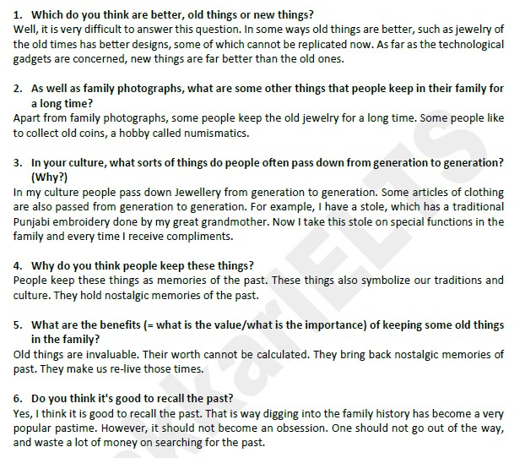

1. **Describe an occasion when you ate a kind of food for first time.**

**Food is one of the three basic necessities of a person food, shelter, and clothing. One must need food to survive in life. Today I would like to talk about a time when I tried a new kind of food for the first time. It was pizza on the first time I ate it at La pinnoz. It was the time when my friend came from Canada. We used to study together in my college days. My friends live in Bardoli. He**[**invited**](https://ieltsdata.org/tag/invited/)**us to visit Bardoli. It was the month of October last year. We went there by our car. We started our journey 8:00 in the morning to reach Bardoli. We took tea after reaching there at my friend’s house which is in sector A. It is a beautiful place. We took rest for 2 to 3 hours. In the evening we went to the sector C with my friends. He told us that pizza on La pinnoz is very delicious here. I had never eaten this food earlier. So, I was very excited to taste this delicious food. We went to the La pinnoz shop. The festival of Diwali was coming ahead. So, there was a discount on pizza usually there is discount on Friday and Monday. But at the same day One medium size pizza was absolutely free with one family size pizza. So, my cousin ordered one family size pizza. We ate it and it was really delicious.**

**I really liked this food. It was made of bread and served hot. Pieces of different vegetables were scattered on it with creamy butter. The tomato sauce was served with it and it added to its taste. We also ordered soft drink which was also served with it to each of us. The place was very neat and clean and there was very good seating arrangement there. There was a small bell hanged there. I asked my cousin about this. He told me that this is to give the compliment about the service and quality of food. If you liked it then ring the bell. So, I rang the bell because I really like both the things.**

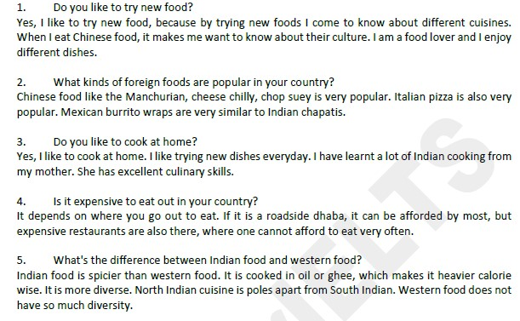

1. **Describe a goal you want to achieve in the future or Describe an ambition that you have had for a long time.**

**I have had ambitions in my life.**

**Some I have achieved and some I have failed to achieve.**

**I have always felt the reason for my failure to achieve a goal has always been associated with my lack of motivation.**

**So, today, I want to talk about ambition that I am really motivated to achieve.**

**The ambition is to settle in Canada for my further studies.**

**I think it all started about five years ago, when one of my close friends, Meet moved there.**

**Before that, I was completely unaware about life in Canada.**

**His words have built a fairy-tale image of Canada in my mind.**

**He told me about the difference in the quality of life between India and Canada.**

**The healthcare and the education system in Canada are miles ahead.**

**There is no corruption; there is very negligible crime, and more than anything else, there is value for labour.**

**Then, Canada’s weather is also to my liking, as I hate the heat.**

**I sweat profusely during the summers in India, and it makes not only makes me uncomfortable but also others around me.**

**Canada’s summers are also quite cool.**

**I also have a habit of googling pictures from Canada, and the beautiful landscapes have only strengthened my resolve to settle in Canada even more.**

**That is the reason I am taking the IELTS exam today.**

**You can see that my English is not great, but I have worked really hard to improve my English for the past few months.**

**It was not easy.**

**I have developed the habit of watching English movies and reading English newspapers for developing my English.**

**I also try and talk with all my friends in English and even ask them to do the same.**

**I know only practice makes perfect.**

**I have also done research on the course and the university I want to apply to.**

**Even if I fail today, I will try again- because I am really motivated to fulfil this ambition.**

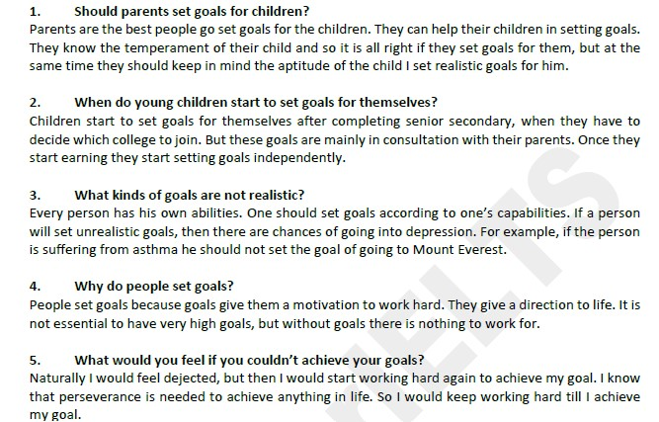

1. **Talk about a toy you liked in your childhood.**

**Well, talking about childhood toys makes me nostalgic. In my perspective, childhood is the golden phase of one’s life, and memories related to it would always hold a special place. Plus, what could be more precious than a childhood toy? Since I was the apple of my family’s eyes, I was fortunate enough to have a myriad of toys such as stuffed animals, building blocks, puzzles, handmade toys and many more. However, one toy which was close to my heart was a toy train, which my father gifted me on my 6th birthday.**

**I vividly remember my first train trip along with my parents, that time I saw an original train for the first time. I was awestruck by its enormous size, fascinating colour, and sound. The first word came from my mouth was,” I wish if I could have something like this to play with at home”. Just after a couple of months, on my birthday morning, I saw a large gift-wrapped box in my room. I wanted to open it, but out of the blue, all my family members started to sing a birthday song.**

**Gauging my inquisitiveness, my dad asked me to unwrap it. I was over the moon to see my favourite toy. Immediately I went to my dad and gave him a huge hug. It looked exactly the miniature locomotive, with a cute red steam engine, 3-4 bogies along with some track’s parts. My dad helped me to assemble the train tracks and fix the train. I still remember the sound and lights of my toy train. I was extremely passionate about this battery-operated toy train and used to play now and then.**

**Although I was possessive about my belongings, I shared this toy with my siblings and buddies. It helped me to develop both my social and motor skills. At that time, we did not have the privilege to play with hi-fi electronic or battery-operated toys, which is readily available to contemporary generation kids.**

**Only simple toys were our valuable possessions, and I had a whale of a time playing with this toy in my childhood. Moreover, I have a special bonding with this particular toy as it was the first thing my dad gave me without me asking for it, which enhanced both my creativity and imagination.**

**1. What is the difference between girls’ and boys’ toys?**

Traditionally, women used to enjoy toys like dolls, kitchen sets, Boys normally preferred competitive toys such as guns, automobiles, and items to construct and items, which make a good deal of sound. Another difference was that boys usually picked blue, brown and green. These differences have been disappearing over the years.

**2. Do you believe toys really assist in children’s growth?**

Yes, toys play a big part in children’s development. It helps to develop their motor and sensory abilities and their cognitive abilities. At the same time, in addition, it leads to their social growth, particularly when they play with other kids. Kids also learn responsibility when parents request them to correctly store their toys.

**3. Does modern technology have an impact on children’s toys?**

Yes, modern technologies have a big impact on toys. Both the Kind of Toys available and also the children’s preferences for toys have changed over time. Today robots, app-controlled cars are more popular. Board games are becoming less and less popular. Straightforward action toys and figures have also become much more detailed.

**4. Have we lost our hands skills such as sewing?**

Sewing by hand has become a thing of the past. Sewing Machines come up in a big way. But guide sewing machines continue to be used. These possess a hand pedal or a foot pedal. My mother has a completely automatic computerised sewing machine, but she must operate it herself when she sews.

**5. What toys are popular with children in India now?**

Many kinds of toys are very popular in India. Children like wooden toys as well as other mechanical toys; however, electronic toys are quickly gaining popularity.

**6. In general, do kids today have many toys?**

Yes, they do. When I look at the children, I feel that they have too many toys. I never had so many. I believe parents, now, are substituting time that they have to spend with kids by giving them more and more toys.

**7. Do you believe playing with electronic toys has a good influence on children?**

Yes, electronic toys introduce children to technology. They increase the strategy forming abilities. They are great, but when kids spend too much time on digital games, they forget everything else and then these become unfavourable.

**8. Do you think there are some toys which are just acceptable for girls and a few who are only acceptable for boys?**

Not any longer. Gender Differences are evaporating fast, and boys and women play with identical kind of toys nowadays.

**9. Which do you believe is better, for kids to play with toy alone or with other children?**

It is definitely better for kids to play other kids. They learn to care and to share along with many other social skills when they play together with others.

**10. Do you think parents should encourage their children to share their toys with other children?**

Yes, undoubtedly. They Ought to encourage their children to share their toys with other kids. In this manner, they won’t need to have many toys.

**11. How are toys today distinct to toys of yesteryear?**

Now we have electronic toys, whereas we had wooden toys and plastic toys.

**12. How can you believe toys will change in the future?**

What the future holds in store for us no one can tell, however as far as I can see, there will be more and more electronic gadgets in the future, which the children will play with as toys.

**13. If you were planning to give a present to your child, what could you give him?**

I’d give a child a book for a gift. He may not enjoy it at first, But it is going to shortly develop the habit of studying a single day. I feel that books are the best gifts. They remain with that person forever.

**14. What Types of Gifts do parents contribute to their young kids?**

Pendants give all kinds of gifts to their children. They know the need for their kids and give presents accordingly. Most parents give educational gifts, where the child can find out something in an enjoyable way.

**15. Is it good to Give kids too many presents such as a lot of toys?**

No, it is definitely not good to provide a child too many gifts. Kids do not appreciate the value of toys when they are given a lot of toys. It also decreases their creativity and imagination. They also don’t know to share with other kids.

**16. Some parents don’t spend much time with their child but instead, offer the kid gifts as a way to show their love. Do you feel this is good enough?**

No, I do not think this is great enough. The Moment Been didn’t spend with the children is more significant than the gifts they give them.

1. **Describe a country where you would like to work for a short time.**

**In today's era of globalization, everyone wants to explore culture of different countries.**

**The growth of aviation sector has made it possible for people to move to different nation either to work or for recreation.**

**People from developing countries like India have a strong desire to settle in developed nations like India, UK, Australia, and New-Zealand.**

**In my case, the country in which I would like to work for a short period of time is Canada.**

**Many of my cousins are already settled in Canada and they always suggest me to move to Canada.**

**So, I have decided to go there for higher studies.**

**Actually, in Canada, students can work 20 hours a week while studying.**

**In this way, students can manage their expenses without being a burden on their parents.**

**Moreover, In Canada, people are remunerated on the basis of the number of hours they work in a day.**

**In addition, the government has decided fix pay for people working in every sector to make sure that no one is exploited.**

**There are the reasons why I would like to work in Canada.**

**Apart from this, I would like to work in a IT Office or in a cafe while studying.**

**Being an extrovert, I like to meet new people and make them my friends.**

**By working there, I can meet new people every day and can learn about their lifestyle and culture.**

**Furthermore, I will become independent and will learn about how to deal with financial matters effectively.**

**Besides this, the Pay scale of people who work in a restaurant or bar is also high compared to other part-time jobs.**

**So, I would definitely like to work for a short period in Canada.**

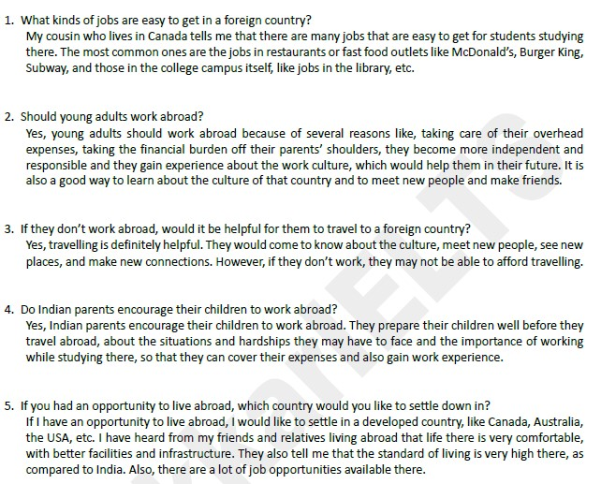

1. **Describe a time when you forgot something important**

**In today’s contemporary era, everybody follows a hectic schedule and always runs out of time.**

**In the quest of satisfying material desire, sometimes, people forget some crucial things and consequently, they land in trouble.**

**Being very retentive, there are very few incidents when I forgot something important.**

**Here, I would like to talk about a time when I was rebuked by my parents against something I had forgotten.**

**I vividly remember it was in the month of April last year. I was traveling to my paternal parents’ home.**

**I was very excited to spend my vacation at my paternal uncle’s house.**

**I had to carry a piece of gold jewellery which belonged to my paternal grandmother and I had to deliver her safely as my grandmother had to wear that jewellery on their 70th marriage anniversary.**

**I was over the moon to meet my childhood friend at my paternal parent’s home, so I forgot to take that piece of jewellery with me.**

**When I was half the way, I remembered it. I was scared so I decided to rush down to the train to go back home.**

**The distance between home and where I was going was 70 miles.**

**I knew that my parents would come in the evening from the office and I had to rush before they arrive.**

**Unfortunately, when I reached home, they were at home. I was totally shocked, and they were too.**

**They asked me the reason why I did that, and then I described it all.**

**My mother started scolding me for this mistake while my father was a little worried about any kind of mishappening.**

**I was down in the dumps and felt ashamed for myself.**

**This session went on for half an hour, and I was set free after verbal torture**.

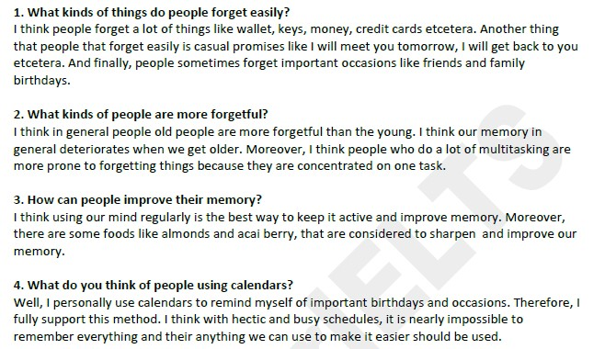

1. **Describe a line that you remember from a poem or song.**

**Well, in my childhood I learnt many poems and heard many songs such as twinkle twinkle little stars or Baa Baa Black sheep. Every time I listen these, I recall those school days and I would like to talk about the poem Johnny Johnny Yes Papa, eating sugar no papa which is my all-time favourite and I heard it for the very first time when I started my school.**

**As we know young kids enjoy rhymes a lot, so our school teacher used to make us sing these rhymes all day long. She taught us some hand moment also and I used to look very cute while singing the poem. I also sometimes sing this poem with my classmates and friends in our spare time.**

**I used to keep on singing this rhyme all day long and my parents also often make me sing for guests especially. In those days we had no air conditioner and we used to sleep on terrace under the open sky and before sleeping my ‘PT mother used to tell me about the poem and used to sing this poem as a lullaby to put me to sleep. In fact, I remember my voice clarity was way superior to other kids in the class that’s why, I was chosen by my teacher to sing this rhyme in the annual function. My school organises annual function every year and I usually wait for annual function because its my favourite function in school. At the day of the function, I was wearing a shirt and a pant and I was dressed up like a father where and I also received my first prize for my performance. I am still keeping this small trophy than I received in my study section and I often recall the childhood memories associated with this particular poem.**

**1. Are you good at memorizing things?**  
Honestly speaking, I am not too good at remembering things, but I always note all essential items on a diary such as meetings, appointments and much more and sometimes I also set the alarm, which reminds me of time.

**2. Do you think children like the rhythm of songs or poems?**  
Yes, I think it is easier for a child to learn songs or poetry, and there are many reasons for it. First is that children do not have any responsibility, which helps them to focus on their studies. Another reason is, in childhood, a child’s brain easily more receptive, which learns and remembers new things.

**3. Do you think it is easier for children to learn songs or poems than adults?**  
I think, yes. I remember in my childhood, I used to memorize many poems, and I did it very easily. I don’t think I can do the same now. I think it may be because, in childhood, our brains are more receptive.

**4. What can people learn from songs or poems?**  
Poems and songs help people to keep in touch with culture, tradition and language. Words used in songs and poems represent the culture and history full of recession.

1. **Describe a tradition in your country.**

**Well, there are many traditional values in my country, and these are observed to preserve the local culture. However, there are many traditions that people follow.  
I would like to talk about the tradition of touching the feet of elders for a blessing.  
This tradition is in practice since times Immemorial. It originated in Gurukuls, where students used to touch their guru’s feet to take their blessings. Later it became a common practice to touch the feet of elders or seniors for blessings.  
This is something every parent teaches to the children to learn the importance of giving respect to seniors and keeping this tradition alive. For example, I start my every morning by touching my father’s feet and my grandfather, and their blessings keep me in high spirits all day long.  
Unfortunately, these days many modern parents are not giving this value to their young ones because of which they are getting detached from local traditions and cultures, and it can be a huge loss to the nation if this practice becomes obsolete. Therefore, it is important to put every effort to keep the rituals and traditions alive forever.**

**1. What is the importance of traditional festivals?**  
Traditional festivals are significant because it brings family and friends together. Moreover, people forget all their tensions and feel very happy and relaxed while celebrating festivals.

**2. What’s the difference between festivals now and in the past?**  
I think now people forget the history of festivals, which means there is a story or a historical fact behind the festival. People are celebrating festivals for enjoyment. However, if we talk about the past, people, even every child was known the meaning and story/reasons for the celebrations.

**3. Do you think western festivals like Christmas are replacing traditional festivals in your country?**  
Well, people are indeed adopting western culture, and they are celebrating festivals like Christmas with their friends and families. But it does not mean people do not celebrate their traditional festivals. They celebrate both types of festivals with the same energy.

**4. Do you think it is wrong for children not to celebrate traditional festivals?**  
I believe that festivals spread happiness. However, today’s generation shows less interest in traditional festivals, and it is because of the busy routine and technology. They are busy on their mobile phone instead of spending time with family and friends and celebrating festivals.

1. **Describe a person who you think is very open.**

**I think very few people today are open and frank.**

**I myself am not very open, and I don’t find it easy to express my feelings.**

**But I really think that my mother is a very open person.**

**I have experienced her straightforward nature many times.**

**She doesn’t hide her thoughts and feelings. She openly expresses them.**

**For example, I recently made a cake.**

**She found it too sweet and when I asked for her opinion, she clearly said she didn’t like it.**

**And she isn’t like that with us family members only, but others also.**

**She speaks her mind.**

**Sometimes people get offended due to this too.**

**But as people get to know her, they understand that she is just straight forward and she intends to help and not to insult.**

**Over the years, I have found that more and more people appreciate her for straight forwardness rather than take offence.**

**Her straight forward and direct nature is also a reason, many of our relatives and neighbours come and share their worries with her.**

**They know she will speak her mind.**

**I think it requires a lot of courage for a person to be open and direct.**

**I care too much about other people’s feelings, and as a result, sometimes I lie or make promises I can’t keep.**

**My mother never does that, and I think she is really brave deep-down.**

**She is very secure about herself, and she is not afraid to show her true self to people.**

**I really wish I could be more open like that.**

**1. Is it difficult for Indian people to express their feelings?**  
Yes, Indian people are very emotional and polite compared to a foreigner, so they feel shy while publicly expressing their feelings.

**2. Who do you think to talk more? Children or grown-ups?**  
Definitely children are more talkative as compared to an adult. The first reason for their behaviour is that they do not feel shy while speaking and don’t care about other people they talk about.

**3. What do you think is the difference between boys and girls in expressing their feelings?**  
Generally speaking, girls are more expressive than boys. Boys hide their, feeling but girls do not.

**4. Do you think people are more open than in the past?**  
Nowadays, people are more selfish and self-centred, so they hide many things, and they also want to save their image; that’s why they do not express their feelings openly. On the other hand, people in the past were very helpful and supportive, so they express their feelings openly.

**5. Why do you think people are less open?**  
Answered in the last question.

1. **Describe an old friend again you got in contact with again.**

**Well, people quickly lose their contact with friends, especially school and college friends, in today’s fast-paced life.**

**I also pass through this situation.**

**I lose many friends’ contacts, and it is happening because I am busy with my studies, and some of my friends are too busy in their work, life and some shifted to another place or country.**

**Here I would like to talk about my school friend, whom I found on Facebook. it is not fair to say, but Sometimes my thanks to the Corona pandemic because it slowed down life, and people get time to spend with their families.**

**His name is Meet.**

**We studied for ten years together.**

**His father is a civil engineer.**

**His family shifted to Mumbai to expand the business, so he had to move there.**

**He gave a phone number to me on a slip, but unfortunately, I lost the slip.**

**I missed him a lot.**

**He was a brilliant student.**

**He is not only in good in academics but performs very well in sports also.**

**He was good at math, and sometimes He also taught other students if they found difficulties in that subject.**

**He likes to live very simple means He does not like trendy clothes.**

**Last month I was checking my Facebook account, and I entered his name in the search box, luckily his account showed in the list.**

**I clicked on it and sent a friend request to him. He accepted the next day and also sent a mobile number through the message. After that, we start calling each other.**

**I felt thrilled because I was trying to find out the contact with him for many years. Now, whenever we call each other, we recall our old days and memories.**

**1. What is the influence of social media on friendships?**  
I think social media has definitely enabled us to maintain friendships better. We all know our friends are just a click away. At the same time, it has all reduced face to face contact, and I think that has weakened the bonds of friendships.

**2. Why do people lose contact with each other after graduation?**  
I think the main reason is that we get busy with jobs. Moreover, sometimes people move to another city for a job. We don’t see our friends daily, and we come in contact with new people. Building new friendships consumes time, and thus inadvertently people lose touch with friends.

**3. Do people in your country like to make new friends?**  
Definitely, I think Indians, in essence, are very social. We love conversation, meeting new people. Every time, I travel, I come back with a new contact in my phone.

**4. Do you think old friends are more important to the old generation or the young generation?**  
I think old friends are important to both the new and old generation. I think talking with childhood friends takes people back to childhood days in some sense, and most people miss that time – a time free of tensions and worries.

1. **Describe a family which you like and are happy to know.**

**The family plays a vital role in every person’s life. I know many families, some are my relatives, and some live in our neighbourhood, and mostly they are polite and intelligent.  
Here I would like to talk about a family that comes to our society four months ago. I enjoy spending time with them. They belong to Gujarati culture.**

**There are six members in the family, Mr. Patel, his wife, his parents and two children. Mr. Patel works in the Reliance company. They lived in Mumbai before they shift here.  
Families belong to different religions live in our society, and there is one rule of our society to organize a dinner party whenever a new family comes into our society.**

**So, I meet them the first time at the dinner party; they are very decent people; their children are brilliant and well mannered. The Father of Mr. Patel, retired from Army, and his mother is retired from a government bank.**

**I feel very happy when I came to know that Mrs. Patel is an English teacher. I requested her to teach English because I am preparing for the IELTS exam. She gets ready to teach me.**

**Now I go to their home every evening from 5 to 7 pm for speaking and writing. She is a very polite lady and never gets irritated if I asked some questions again and again.**

**I noticed one thing in their house and that everything is well placed and they do not force their children to do something; in fact, they support their children’s decision, which I like.**

**1. Who is usually the leader in an Indian family?**  
India is a patriarchal society, and, in most families, the eldest male member is the leader. If it’s a joint family, its generally the grandfather and in nuclear families, it’s the father.

**2. How do grandparents take care of their children?**  
I think today grandparents fill the void left behind by working parents. Both the parents work today and as such, are not able to devote enough time to the children. So, grandparents raise children just like parents. They also teach them about moral values. In some ways, they are also responsible for spoiling children as they give in to their demands much more easily than parents too.

**3. What’s the most important quality of a good parent?**  
I think the best quality of a good parent is flexibility. Flexible parents tend to be open-minded and easy-going. They resolve disagreements smoothly. Kids are naturally defiant, and thus, inflexible parents increase defiance and rebelliousness in their kids, and this always escalates conflicts.

**4. How can new parents learn about parenting?**  
I think there are many ways to learn about good parenting. They can read books on parenting. They can join parenting classes, they can watch video on you-tube about parenting and last, but not least, they can take guidance from their own parents.

1. **Describe an energetic person you know.**

**According to my perception, an energetic person is that who is always ready for action, either is physical or mental—a person who does not feel tired.**

**Here I am going to talk about a very energetic person.**

**Her name is MS. Parul.**

**She lives next to my home.**

**She is a teacher of mathematics in the private school.**

**There are five members of her family, her husband, father -in- law, brother- in- law and four-year-old son.**

**All members of her family are working.**

**She is the only lady of her family, so she has to manage household chores and school work.**

**She wakes up at 4 am.**

**She starts her day with prayer and then begins other household chores such as dusting, mopping, washing clothes and preparing breakfast for all.**

**She completes all this work at 6 0′ clock.**

**After that, she gets ready for her son to school.**

**She leaves home at 7 o’clock and comes back at 3 o’clock.**

**Instead of taking rest, she teaches math to 10 students from 4 to 6 0′ clock in the evening and then she completes the rest of the house chores and prepares dinner for the family.**

**She goes to bed at 10 o’clock. So, this is her daily schedule.**

**I think she is a brave lady who manages all this very calmly.**

**I know her very well because I am not only her neighbour, but was attending math class in her home last year.**

**She is a big motivation for me.**

**Even though she is very busy in her personal and professional life but still maintains her physique very well because she does yoga in the morning.**

**1. What kind of jobs need a lot of physical activity?**  
I think with the coming of computers and technology, a lot of jobs don’t require as much physical activity as in the past. Still, there are a few jobs that involve manual labour like masonry, plumbing, painting etc. which involve a lot of physical activity.

**2. What’s the difference between payment for physical work and payment for mental work?**  
It’s a fact that today as a society, we give more importance to mental work as compared to physical work. So, jobs that require mental work entail a much higher salary than jobs with physical work. In India, especially, jobs with physical work like farming, plumbing, painting, working in factories are some of the least paid jobs.

**3. Can physical workers have higher salaries in the future?**  
On the contrary, I think physical workers would have even lower salaries in the future relatively. This is because machines are gradually replacing manual work, and I think the need for manual labour is coming down tremendously.

**4. Do you think machines could replace manual labour in the future?**  
I don’t think machines will replace manual labour completely, but there would definitely be an impact. I think with the coming of new technologies, new types of jobs will be created, which will require different skill sets. This, in fact, is already visible for example, with the coming of driverless cars – there has been a fall in the jobs for drivers.

1. **Describe a time you saw children behave badly in public.**

**It can be understandable if children who are below then four to five years old are misbehaving other because they do not know how to behave outside the home, but parents have to be punished their children who are above then six years old if they embarrass the parents in the public place.**

**I saw such kind of situation in January this year at a wedding party.**

**I went to my friend’s home, Ahmedabad, a few months ago to attend her sister’s wedding.**

**I arrived a day before the party.**

**There were many guests present there. And also, there were many kids attending the function.**

**We know that many children are gathered in such kind of occasions.**

**Most of the children behaved very well, but I explained a situation when I saw some children misbehave.**

**The function was organized in a public hall.**

**On the marriage day, all were looking very well.**

**Suddenly I heard some noises.**

**When I reached the spot, I saw some children fighting with each other.**

**Everyone was trying to know what was the actual reason for fighting.**

**Children did not want to hear anything even as they were speaking very badly with elders.**

**Their parents also felt insulted after some time.**

**We came to know that one child was speaking bad jokes to others and other children tried to stop him, but instead, stop the speaking child pushed other children who were trying to stop him.**

**This increased the fight.**

**Their clothes were torn.**

**They did not realize that they were spoiling the whole function.**

**Everyone got angry and raised questions about their parenting.**

**A man besides me tried to calm down the fight. After a specific time, children apologized for their mistake.**

**1.** **What bad behaviour do children usually have?**  
Normally, the bad behaviour I associate with children is creating noise, breaking things, disrespecting elders, scribbling on the walls and stealing small things like pencils, erasers. I think I am guilty of each one of them when I was young.

**2.** **How should parents stop their children from behaving badly at public?**  
I think parents should stop their children from doing bad things at home and misbehaving with others. There should be no double standards. Moreover, I think parents should not just stop children from doing something bad but also tell them why it is bad to do it.

**3.** **Are parents these days stricter than in the past?**  
On the contrary, I think parents are more lenient these days. I think it is mainly due to two reasons, first being the strict laws against physical punishment and the second reason is the influence of western culture.

**4.** **Whose influence on children is more? Parents or their Friends?**  
I think in the early years, the parents influence is second to none as children spend the majority of their time with the children. But as children grow older, they spend considerably more time with their friends, and I think during these years, it is their friends that influence their behaviour and thinking the most.

1. **Describe a conversation topic you are not interested in.**

**A lot of bad things are happening in the Corona Pandemic period. People are free in their houses, but they do lots of conversation on useful and useless topics. I also do a discussion on many issues with my family and friends, but sometimes I get irritated from that particular discussion. Here I am going to talk about a conversation in which I was not interested. Last week all my cousins and other family members were gathered at my house. We did lots of things together, such as watching movies and playing games.  
Suddenly, my uncle was watching the TV and Kangana Ranaut’s office news was telecasted on it. The news was related to Kanagana Ranaut’s demolition of her office. I saw this news before on social media. Elderly members of my family started discussing it; my cousin also took an interest in it. I also joined the conversation but for some time. After fifteen minutes, I fed up, so I picked my mobile phone and started playing games on it to pass the time.  
I didn’t want to continue the discussion because no one could really know what actually happened with that particular matter. We should wait for the court result. I do not understand why people, including my family, take an interest in such kind of sensitive cases, especially which are belong to Bollywood.**

**1. What topics do young people in India talk about?**  
The youth in India talk about nearly everything from politics to sports to fashion to technological gadgets. Personally, I love to talk about mobile phones computers and sports with my friends.

**2. What is the difference between topics that are popular now and topics that were popular in the past?**I think earlier people didn’t care so much about technology, but it is a major part of the conversation now in this generation. I also love talking about that. In addition, I think rest of the topics like sports, fashion and politics were actively discussed in the past too.

**3. How do you know if others are not interested in the conversation?**  
I think I mostly see people’s facial reactions to see if they are interested. If they are laughing at my jokes or their facial reactions are changing as the tone of the conversation changes, they are interested. Otherwise, they are not. Sometimes people are direct too. They try to cut me off and steer the conversation towards another topic.

**4. What’s the influence of modern technology such as the internet, emails on our communication?**  
I think they have increased the overall communication, but at the same time, they have also decreased face to face communication. Moreover, they have reduced the importance of language and grammar in communication. People care more about being concise rather than being grammatically correct.

1. **Describe an expensive activity that you enjoy doing occasionally.**

**I do many things in my free time, including playing games (indoor and outdoor), watching reality shows on TV and listen to music and much more. My hobbies are quite economical, excluding one, and that is, driving a supercar (Jaguar or Audi) around the town because it was my dream when I was 10 years old that I want to ride once a super car. And after age 18 I had an experience driving a super car.  
Occasionally, I like to drive a super car around the city. I do it three times in a year because the charges of super car are 5000 to 10000 per hour. I hire a different car every time to get a new experience.  
Generally, I go on the drive alone, but sometimes my friend gives the company to me. I clicked a lot of pictures in and outside the car and posted these pictures on the social sites like Instagram and Facebook.  
The actual price of the super car is too expensive about one core, so that’s why they charge rent in thousands.  
I love driving, and I want to experience luxury cars. I feel thrilled and satisfied. I do lots of things whenever someone gives a company to me. That’s I eagerly wait for it. So, this is the expensive activity which I had done it.**

**1. What kind of expensive things do people like to buy?**  
I think it varies from person to person, but generally, expensive things people buy involve clothes, technological gadgets like mobile phones and cars and motorcycles. The most expensive product that I own is a Dell Gaming laptop.

**2. What the difference between men and women in buying things?**  
I don’t think there is a major difference today. However, men sometimes make extravagant purchases like a costly watch or a mobile phone. Women, I think make purchases after careful consideration. They like to buy different clothes as per the new fashion.

**3. What are the advantages and disadvantages of being rich?**  
I think the biggest advantage of being rich is that you can prioritize your health and fitness over anything else, while poor people sometimes have to sacrifice their health for money. The biggest disadvantage of being rich is that people are always ready to fleece you. People don’t feel guilty about cheating a rich person.

**4. Why are some of the sports expensive? Are they for everyone?**  
Some of the sports, especially adventure sports, are expensive because they require licenses, trained professionals and expensive safety equipment. No, I don’t think everyone can afford them. Also, they are not for the faint of heart because of the risk involved.

1. **Describe an area of science that interests you.**

**Science is very important part in a student’s life. It’s through the science subjects that we begin to think logically and find answers to our questions.**

**Honestly speaking, I am not too fond of science, especially physics and chemistry, but I always like to learn biotechnology.**

**It is an exciting subject. It is not only about the human body, but provides the information about plants and animals also. I was not having interest in biology but after my friend told me about that.  
I started taking an interest in that subject when I was in sixth class. I used the internet along with books and notes, which were provided by class teachers.**

**As internet is the best source. I think the best way to learn a practical subject because a student can watch different videos of a single topic from internet, which makes it easy to understand the challenging topic and can get better understanding from videos which are on the internet.  
I like biotechnology very much because, with the help of this subject, now I know very well about how to maintain the body physically and mentally fit. Moreover, I had also got knowledge about animals and plants through biology like how plants survive. I am fond of planting, and I have planted a variety of flowers and various plants in my home.   
I truly take care of these very well because I have excellent knowledge about the environment, and also, I love taking care of plants. It is possible with the help of biotechnology. So, these are the things which I like about science.**

**1.** **What’s the best invention in the past hundred years?**  
I think there are many inventions which have transformed our lives, but I think the invention of the internet has had the maximum impact. Today, we have endless information available at our fingertips, and we can communicate with anyone sitting anywhere.

**2. What’s the influence of science on human life?**  
I think there are two main influences of science. First, science brings logic and reasoning in human life. It reduces the impact of superstition and makes us more open-minded and accepting of others. Second, science and inventions have made our life much more comfortable as compared to the past.

**3. What can individuals do for scientific research?**  
I think most science inventions happen accidentally. Individuals see a need, and they come up with an idea to address that need. That is how new inventions take place. Individuals can also donate money to the scientific organisation to fund scientific research.

**4. What influence can international cooperation in science bring about?**  
There main challenges to scientific research in today’s time is the lack of funding and lack of access to information. International cooperation can address both of them. If countries share funds and their knowledge, scientific research would definitely receive a boost.

1. **Describe a prize that you received.**

**I have always believed in working hard and not worrying about the outcomes.**

**But I would be lying if I said that I didn’t actually care about prizes.**

**When I was in school, I took part in an inter-school quiz competition. But, just before the inter-school quiz competition, we had our mid-semester exams.**

**So, I couldn’t really pay much attention to the competition.**

**Despite that, I came first in the competition and received a gold medal.**

**And this made it all the more special.**

**The quiz was on different topics from science to maths to general knowledge.**

**I went into the competition with no expectation of winning.**

**I just didn’t want to embarrass myself.**

**But, two things worked in my favour.**

**My general knowledge has always been good because I read the newspaper daily.**

**I don’t even skip reading the newspaper on exam days. It is a part of my daily routine.**

**I couldn’t specially prepare for the other topics, but a lot of the topics were similar to my school topics.**

**So, when I was preparing for my school exams, I was also in a way preparing for the quiz.**

**I still remember the day of the exam.**

**I woke up on the day feeling really nervous.**

**In the first round of the quiz, I answered one question, then another and then another.**

**At that time, I felt I was just lucky.**

**But by the third and fourth round, I felt a lot more confident.**

**One of the other participants was also very good.**

**In the last round, it was like direct competition between both of us.**

**However, I came on top by a slight margin.**

**Immediately after the competition, I was awarded the gold medal.**

**I remember feeling very happy with all my teachers and peers congratulating me.**

**It was all so surreal.**

**I still get emotional thinking of that day sometimes.**

**So, this is the prize I received from school.**

**1. What kind of prizes do students get?**  
I think the main prize that students receive are for topping the exams. Besides that, there are various competitions in schools like sports competitions, debate competition, quiz competition, dance and singing competitions, which entail prizes.

**2. Should students get the same prize in sports and academics?**  
I think yes, sports and academics are the same in my eyes. I think they both have their own importance. Therefore, a student who excels in sports should be awarded the same way as students who excel in academics.

**3. Why should people be awarded?**  
I think awards are foremost recognition of a person’s efforts and hard work. They also build a spirit of competition. In other words, awards make people more motivated and work harder. I think very few of us are self-motivated, and awards act as an external source of motivation.

**4. Are awards always good for the winners?**  
No, I don’t think they are always good. They can also create a feeling a superiority among the winners that they are better than others. This in return, can also create a feeling a complacency among the winners and stop them from working with the same level of dedication and commitment as they did before.

1. **Describe a time when you first talked in a foreign language.**

**India is a diverse country, and it is tough to learn all Indian languages because languages vary from state to state.**

**So, in the case of a foreign language, it is a big challenge to learn and speak the other country’s language.**

**Today I am going to talk about a time when I used a foreign language to make conversation with a child.**

**I think the first time I talked in a foreign language It was the occasion of a family get together.**

**My maternal uncle came from France with his family four months ago for ten days.**

**He is doing a job in an IT company there.**

**There are three members in his family, uncle, his wife and five-year-old son.**

**My uncle and aunt speak and understand our language very well, but his son knows English and French.**

**Luckily, I know a little bit about the French language because I am planning to shift to France for further study, so I joined French language classes five months ago. And had also done practises in my coaching with this language so I’m able to speak French somehow.  
I know the basic words such as  
Good morning =Bonjour  
Yes = oui  
No=non  
Thank you = Merci**

**So sometimes, when I was with my uncle’s son, I gave the answers to his few questions.**

**Even though the English alphabets are used in French, but it is not very easy than English.**

**I feel very nervous while speaking French.**

**So that was the first time when I spoke French.**

**1. At what age should children start learning a foreign language?**  
With regards to learning a foreign language, I think the earlier, the better. So, I think primary school is the best stage to start learning a foreign language. Young children have less inhibitions and don’t hesitate while speaking. Also, there is a lot of burden of studies in secondary school.

**2. Which skill is more important speaking or writing?**  
I think both are equally important. A few years ago, I would have said that speaking is more important, but with the coming of the internet, we have started communicating in the form of emails and chats and so writing today is equally important.

**3. Does a person still need to learn another language if he is good in English?**  
I think learning another language is always beneficial. Bilingual children are better at multitasking and thinking out of the box. Learning another language also helps in the mental development of children. I think I have read it at many places that bilingual children outperform monolingual children academically.

**4. Do you think minority languages will disappear?**  
Unfortunately, yes. I think it is already happening. There are many reasons for it, but the primary reason is English is prioritized in most of the countries as it gives a competitive advantage in jobs. Moreover, linguists around the world are also not doing enough to protect minority languages. There is research into minor aspects of languages like English and French, while minority languages are completely ignored.

1. **Describe a good decision you made recently.**

**Undoubtedly it is true that decisions play a vital role in our lives. One right decision makes life: on the other hand, one wrong decision can spoil one’s future.**

**The Corona Pandemic has slowed down life considerably.**

**In fact, during the first few days after the lockdown was announced, everyone took it very seriously.**

**Precautions were taken. Rules given by the government had being followed.**

**However, lately, people have become a lot more complacent.**

**As a family, for the past few months, we avoided going out unless it was absolutely necessary.**

**We were also shopping online instead of visiting stores.**

**However, last week my father decided that we will visit the wholesale store Fair Price to buy groceries.**

**He believed that it would be fine if we took precautions like wearing a mask and using sanitizer after every fifteen-twenty minutes.**

**But I was getting a very bad feeling about it.**

**I thought the cases were increasing sharply, and it was not the right time to step out.**

**We could order all those online, although for a slightly higher price.**

**So, I convinced my dad that it was not the right time.**

**I told him that we might save a few Rupees, but it was worth putting our lives at risk.**

**My mother also supported me, and so my dad relented.**

**We made a list of things of all the things we wanted to buy and ordered them online**

**A few days later, we heard that many people had become infected after visiting Fair Price**

**It was a being labelled a super-spreader by the news media.**

**When we saw the news, we breathed a sigh of relief.**

**My father told me that I took a wise decision.**

**After the event, we have become even more cautious.**

**I do believe that life must go on, but life cannot go on in the same way as before.**

**We all need to take some precautions and now more than ever as the cases are increasing. So, this is the decision I had made recently.**

**1. What decisions do people make every day?**  
I think we all make plenty of decisions everyday like what do buy, what to eat, what to watch on television and what to say to others. Then, there are decisions people have to take related to work and so on.

**2. Why do people make decisions?**  
People make decisions to feel in control. Decisions give us a feeling that we are the masters of our fate. No one else can control our fate. Decisions also give direction to our life. Every decision has a consequence and it takes our life in a certain direction.

**3. Can children take decisions on their own?**  
Yes, I think even children can take decisions on their own, but I also believe their likelihood of making a mistake is higher than others as they are worldly-wise. Thus, parents should take decisions for children when they are young and gradually as they grow up, allow them to take decisions on their own.

**4. When do people change their decision?**  
I think changing a decision is all about our conscience. When we get that feeling inside that we have made a mistake or we are doing the wrong thing, we try and change our decision. And if we don’t change our decision, we always feel guilty about doing the wrong thing.

1. **Describe an event you attended in which you didn’t like the music played.**

**I love listening to music.**

**In fact, I listen to music while driving, while cleaning and even while studying/working.**

**And I generally enjoy all genres of music from pop to rock to jazz.**

**But few years I attended a concert by Arijit Singh, as he is my favourite singer and world’s most popular male singer but I didn’t enjoy the concert one bit.**

**There were mainly two reasons for it.**

**First, Arijit himself didn’t show up.**

**I was and still am a big Arijit Sing fan, and it was a great disappointment.**

**The greatest singers of the world could have come to the stage and I would still have been disappointed.**

**I was really looking forward to hearing Arijit live for the first time.**

**So, I was very disheartened.**

**The second reason was the backup singers seemed like amateurs.**

**They didn’t involve the crowd at all.**

**Their performance was very dull and monotonous.**

**I didn’t feel like I was attending a live performance at all.**

**In fact, after a while, none of us were paying any attention to the songs being played.**

**The music was also too loud, and it was hurting the ears.**

**I remember many people asked the event managers to lower the volume of the loudspeakers.**

**What added insult to injury was that the event managers refused to refund the money.**

**Some of the people even fought and got their money back, but I was too tired to fight then.**

**I left the concert quite early.**

**More than anything else, I never got an opportunity to hear him live again, I don’t know if I will get an opportunity in the future too.**

**It might remain a dream.**

**1. Why do so many young people spend a lot of money on concerts?**  
I think it is mainly because of the experience. Hearing a singer on the screen can never match the feeling of hearing them live. Also, I think it’s about spending quality time with friends.

**2. Do you think older people like the same music as young people?**  
I feel young people like pop, rock music, basically any music that they can dance to. They don’t care about the lyrics; they care more about the fast beats. Old people are more into soft, slow, music. They actually pay more attention to the lyrics.

**3. Do you think music concerts are suitable for old people to attend?**  
I think it might be physically taxing for the old people to stand for so long at a concert. But otherwise, I think if the old people can manage the physical exertion, the concerts are certainly suitable. Today many concerts also offer chairs, where older people can sit and enjoy the show rather than having to stand.

**4. Why do shopping malls often have background music?**  
I think the music is there to enhance the experience of shopping. We remember shopping through not only sight but also through music playing in the background.

1. **Describe an ambition that you have for a long time.**

**I have had ambitions in my life.**

**Some I have achieved and some I have failed to achieve.**

**I have always felt the reason for my failure to achieve a goal has always been associated with my lack of motivation.**

**So, today, I want to talk about ambition that I am really motivated to achieve.**

**The ambition is to settle in Canada for my further studies.**

**I think it all started about five years ago, when one of my close friends, Meet moved there.**

**Before that, I was completely unaware about life in Canada.**

**His words have built a fairy-tale image of Canada in my mind.**

**He told me about the difference in the quality of life between India and Canada.**

**The healthcare and the education system in Canada are miles ahead.**

**There is no corruption; there is very negligible crime, and more than anything else, there is value for labour.**

**Then, Canada’s weather is also to my liking, as I hate the heat.**

**I sweat profusely during the summers in India, and it makes not only makes me uncomfortable but also others around me.**

**Canada’s summers are also quite cool.**

**I also have a habit of googling pictures from Canada, and the beautiful landscapes have only strengthened my resolve to settle in Canada even more.**

**That is the reason I am taking the IELTS exam today.**

**You can see that my English is not great, but I have worked really hard to improve my English for the past few months.**

**It was not easy.**

**I have developed the habit of watching English movies and reading English newspapers for developing my English.**

**I also try and talk with all my friends in English and even ask them to do the same.**

**I know only practice makes perfect.**

**I have also done research on the course and the university I want to apply to.**

**Even if I fail today, I will try again- because I am really motivated to fulfil this ambition.**

**1. What kinds of ambition do people have?**  
I think ambitions vary with age. In school, student’s ambitions are to get into a good college or a university. Some youngsters with a creative mindset also dream about becoming a successful celebrity or a successful singer. As people finish their education, the ambition is to get a high-paid job in a reputed firm and then after children, children’s ambitions become the parent’s ambitions too.

**2. Why should parents encourage children to have ambitions?**  
I think ambitions give direction to children. It makes sure they are dedicated and less likely to fall off the track. Moreover, if children are ambitious, they are less likely to fall down on failing. They are always willing to try again.

**3. Should parents interfere with their children’s ambitions?**  
I think if parents interfere with children’s ambitions, it would create a feeling of resentment among the children for the parents. It would have disastrous long-term consequences for their relationship. I think parents should be supportive of their children’s dreams, but they can encourage them to keep backups and not put all their eggs into one basket.

**4. Is there any difference of the ambition of grown-ups and that of children?**  
I think grown-up’s ambitions are much more realistic than children because they know that life is full of problems and hurdles. Children, on the other hand, sometimes have very unrealistic ambitions. Children also don’t get much disheartened on failing to achieve their goals, while adults sometimes even go into a depression on failing.

1. **Describe a time when you changed your opinion.**

**I think changing one’s opinion is really hard for some people.**

**But I think it is much better than staying stagnant and being obstinate and stubborn.**

**I have changed my opinion about different things.**

**But I don’t do it easily.**

**I change my opinion only when I am presented with, or I come across a logic which I find factually correct and which contradicts with my previous beliefs.**

**An opinion I changed a few years ago was the about relevance of history.**

**In my childhood, I strongly believed that studying history was a waste of time.**

**It doesn’t teach us anything, and it actually takes away time from subjects like science and math, which are really useful.**

**But when I entered 10th grade, my history teacher opened my eyes to the wonderful world of history.**

**She related each historical event with a situation at present.**

**She told us how by reading history or analysing history, policymakers and administrators could better handle a particular situation.**

**We can lead a lot of better lives if we pay attention to history.**

**She also threw light on our common Indian traditions and their origins in history.**

**It made me realize traditions are much more than just superficial customs practiced for pleasing elders.**

**Some traditions actually have scientific backing, for example, water is stored in copper vessels as the copper ions dissolve in water and purify the ions.**

**With each class, my interest in history and my opinion about history being useless changed.**

**Now, rather than opposing history education, I ardently support it.**

**1. Do children like to change opinion?**  
I think they, but it is hard for them. I think children are more emotional than adults, and this means that they form an opinion based on emotions. Emotional decisions, in turn, are very hard to change because it hurts our ego when we change them.

**2. Why do people change opinion?**  
People change opinion when they find contradicting evidence against their previously held opinion. If they don’t change, they suffer from guilt and thus, although they may resist at first, they slowly do change.

**3. Who do young people turn to for advice?**  
I think young people mainly turn to family or figures of authority like teachers and school counsellors for advice. Some youth also turn to their peers for suggestions. Whom they turn to for advice depends upon the matter concerned and the decisions relevance in their lives.

**4. Do people like giving an opinion about politics?**  
Indian people are very opinionated when it comes to politics, and they are not shy in expressing their beliefs as well. And I think this is good because this means people are politically active and they are thinking about governments decisions and policies. This also means they put a value on their vote.

1. **Describe an intelligent person you know.**

**I know many intelligent people.**

**I find some of my friends, teachers and neighbours very intelligent.**

**Here I would like to talk about my friend Dhwani, who is very brilliant.**

**She is 18 years of age.**

**She is not tall but looks very beautiful.**

**She has curly hair and has sparkling black eyes.**

**We were good friends from our childhood and also know each other very well. She knows everything about me.**

**We studied together from 1st to 10th.**

**Then she chose the medical stream, whereas I opted for commerce.**

**I remember vividly that she always stood first in class.**

**We used to study together at home also because we were neighbours.**

**I was weak at mathematics, but she guided me in such a way that I started getting good grades in mathematics also.**

**She was in the good books of all teachers.**

**She was not only good at studies but also participated very actively in extra-curricular activities.**

**She participated in a state-level quiz show organised by the Rotary Club and bagged the trophy for our school.**

**She has a great sense of humour and can turn any tense situation into a happy one by cracking jokes.**

**She has a lot of ready wits.**

**I just love her company.**

**She has recently taken the IELTS and has scored a 7.5 band overall.**

**She has motivated me also to take the IELTS so that we can study together in some good college in Canada.**

**So, Sonia is the person whom I find very intelligent.**

**1. Are most intelligent people happy? Why?**  
Not necessarily. Intelligent people have high expectations of life. They may feel unhappy if things don’t go according to their expectations. But, at the same time I think it is difficult to generalise. Intelligent people know that happiness is a state of mind, and so they may try their best to stay happy.

**2. Do you think intelligent people are selfish?**  
No, selfishness has nothing to do with intelligence. I think it is personal nature to be selfish. A person who is intelligent may get success in his life and may seem to be selfish, but actually he is not. Even people who are not so intelligent may be selfish. It is basic human nature to look after one’s own interests first. So, it cannot be said that intelligence makes people selfish.

**3. Do you think intelligent people are helpful?**  
Well, a helpful nature also has nothing to do with intelligence. Anybody can be helpful, but intelligent people can help in better ways with their intelligence. People who are not intelligent but have money can help by giving money, but intelligent people can help by educating the poor.

**4. Who do you think plays a more important role in children’s education, parents or teachers? Why?**  
Well, both have a vital role in children’s education. The role of both parents and teachers is different, but equal. So, it is difficult to say, who has a greater role. In social education, parents have a greater role, but in academic education, teachers have a greater role.

**5. What qualities do you think a good teacher should have?**  
A teacher should have good communication skills. Without good communication skills, a teacher cannot teach well. Secondly, he should have depth of knowledge of the subject. Then, he should be impartial. He should have no bias towards the rich or poor students. He should be able to come down to the level of the student to teach well.

**6. How do teachers help children in their education?**  
Teachers help in all possible ways. They work hard to provide good academic knowledge to the students. They have to keep themselves up-to-date with the latest syllabi and teach students according to the requirement of the time. They can also do some career counselling and advise the students any career path according to their aptitude.

**7. Why are some children more intelligent than others?**  
It can be because of genes. Some may be born intelligent. Some children may work hard to achieve that level of intelligence.

1. **Describe a photo of yourself that you like.**

**I have an I-phone X, which has a dual camera.**

**I click many photographs with it whenever I find anything worth capturing.**

**However, I am not very fond of clicking selfies of myself alone.**

**Here, I would like to talk about a group selfie, which I clicked with my relatives in a family function in New Delhi.**

**Last month, there was the ring ceremony of my cousin Rohan.**

**All our family members had assembled at our house.**

**From there, we had to go to Rohan’s fiancée’s house, which is near our home.**

**We were all dressed to our best.**

**We were standing outside and discussing about the ongoing conditions over the country and suddenly my cousin came and suggested that we should click a selfie together and keep it as a memory of that day.**

**He had a selfie stick, included many people in that pic.**

**There are ten of us in that pic. Including me.**

**We all are smiling and looking very happy.**

**This photograph has come out so nice that I have displayed it as my desktop background.**

**Whenever I open my laptop, the memories of that day come alive in my mind.**

**All my other relatives who are in this photograph have a copy of this in their cell phones.**

**It has rightly been said that a good photograph keeps a moment from running away.**

**Whenever I am free, I open my web albums, and old photographs bring back nostalgic memories of the past.**

**This photograph brings a smile on my face every time I see it.**

**1. Do Indian people like to take photos of themselves?**  
Yes, Indian people do like to take photos of themselves. Selfies have become very common nowadays. Smartphones have become very economical. So most young people have a smartphone in their hands, and these smartphones have cameras in the front and in the back. So, taking selfies has become a routine with young people.

**2. What kinds of devices to people like to use for taking photos these days?**  
People use cameras and cell phones for taking photos these days.

**3. Why do some people like to delete photos?**  
Sometimes the photographs may not be good, and sometimes the memory card may be full. So, people have to delete photographs.

**4. Why do some people like to keep photos?**  
Some people like to keep photos because photographs are mirrors of the past, and they want to preserve those memories forever.

**5. Has the way people take photos changed?**  
Yes, the way people take photos has changed a lot. Now digital cameras have become popular. People do not have to worry about wasting precious film. They can take as many photographs as they like. They do not even need to get them printed. They can save those photographs in their web albums. Even a three-year-old child can click photographs.

1. **Describe a person who helps others in his or her spare time.**

**It is very difficult to find those people who are ready to help other people without any expectations.**

**Today, I am going to talk about my neighbour, who does help other people in his free time.**

**His name is Raman. He lives with his family in my neighbourhood.**

**He has two children and his wife is working in the HDFC bank as a bank manager.**

**Not only himself, but his family is also helping poor people.**

**Mr. Raman is tall and handsome; he has done masters in biotechnology and at present he works for a medicine company named Swiss Pharmaceuticals located at Ahmedabad.**

**His working time is from 9 am to 5 pm.**

**Instead, to return home to rest, he goes to a private school which is nearby his house after his job where he teaches poor children free of cost.**

**He teaches 12th class science and commerce students and helps them to select the right career after school.**

**He helps poor children because he thinks children are the future of the country so they can change the world if children get the right education and guidance on time other with, they may select the wrong path such as the criminal world.**

**I feel very proud of this person because he is doing great work.**

**I always try to learn some important skills from him, which are very beneficial for my future. And also, he helps me with my education.**

**So, Raman is the person whom I know that helps others in his free time.**

**1. Do people nowadays help others more than in the past?**  
There have been helpful people in every era, and they use the means they can to help others in need. I believe that people have more means to help other people anywhere in the world because of technology. That was not possible in the past.

**2. Who should teach children to help others?**  
**Parents or teachers?** Both parents and teachers share the responsibility to ensure that children learn to help others. Parents should be role models for their, and teachers can have lessons and activities in schools to inculcate/imbibe this value/**virtue in children**.

**3. In what kind of professions do people help others more?**  
I think in all professions, people help others directly or indirectly through their products and services. However, those working in the social/community service fields, like NGOs working to promote child education, women empowerment, and other such social issues, help others more.

**4. Why are some people willing to help others?**  
People who are empathetic, sensitive, and compassionate are more willing to help others. These values are what they have seen and learned from their parents, teachers and other people around them while they are growing up.

1. **Talk about a prize you want to win.**

**Everyone loves prizes, winning them makes one happy.**

**Prizes also motivate us to work hard and prove the fact that hard work is key to success.**

**I have not won many prizes in my life but one prize I would like to get would be the first prize in marathon race which is held every year at Jogger’s park in my city.**

**The race is organized by Standard Chartered Bank.**

**It is held to spread awareness about diseases like cancer and also to make people aware about the benefits of healthy living.**

**All the money collected from this race goes to a charity. And also, money goes to orphanage home for poor children.**

**The winner of the race gets a cheque of Rs 1 Lakh along with a trophy, gold medal and a certificate.**

**The winner also gets a chance to represent the city in other marathon races held across the world.**

**Every year almost ten thousand people from our city participate in this race.**

**The race is held in the first week of November, normally the first Sunday.**

**Last year one of my best friends won the second prize in the race.**

**He finished the distance of 42 km in approx. 3 hours.**

**After seeing him get the second prize, I felt motivated to participate in the race.**

**I am not a professional runner but since then I have started running.**

**Nowadays I can run 30 kilometres in approx. 2.5 hours and I am working on improving my time.**

**Hopefully I will be ready by November.**

**Preparing for this race has made me healthy and I have also learnt a lot from running.**

**If I do not win this year, I will keep trying until I win the prize.**

**So, this is the prize I want to win.**

**1. What rewards can children get from school?**  
Children can get rewards in the form of certificates, medals, words of appreciation in the classroom or assembly or in the form of notes written to parents. Some other prizes that are given in schools are books, stationary, and gift vouchers.

**2. Should parents push their children to get prizes?**  
I would say that parents should encourage their children to participate in competitions and give it their best efforts. They should make their children understand that if their efforts are sincere, the rewards will follow. Inculcating a sense of competition is important, but making children over-competitive, can have some repercussions.

**3. Is it good for children to compete for prizes at school?**  
It is good for children to compete for prizes as it gives them an opportunity to test their abilities and skills. It also teaches them the importance of putting in their best efforts. Prizes can act as a motivation for many students to participate in competitions, and that, in turn, helps them recognize their talent.

**4. What kinds of rewards can companies offer to their outstanding employees?**  
Companies can offer rewards to employees in the form of certificates, vouchers, bonuses, and other gift prizes. Some companies also offer gifts like holiday packages, etc.

1. **Describe a book that you found useful or Describe an exciting book you read.**

**I have not read many books apart from my textbooks.**

**Here, I would like to talk about a book, which my friend gifted me, and I read it all.**

**I found this book very useful and motivating and would like to read it again.**

**This book is ‘The Wings of Fire’ by Dr. A.P.J. Abdul Kalam.**

**My friend got this book as a prize when she participated in a declamation contest.**

**It is Dr. Kalam’s autobiography.**

**It was first published in 1999.**

**This book became popular only after Dr. Kalam became the President of India.**

**He was sworn in as the president of India on 25th July 2002.**

**Mr. Arun Tiwari helped Dr. Kalam in writing the book**

**In this book Dr. Kalam says why he wrote his autobiography.**

**This book is very motivating.**

**From this book, I came to know all about the life and achievements of Dr. A.P.J. Abdul Kalam**

**Dr. Kalam was born in a very poor family in the southern parts of India at Rameswaram.**

**The reason why I admire him is that his life shows how & ordinary boy from a deprived class (poor family) could reach the highest level of the nation.**

**He became not only the best rocket engineer but also the first citizen of the nation.**

**It is true that he described his post as the President as a piece of luck, but his achievement as a rocket engineer was because of sheer hard work.**

**He is a role model for one and all.**

**The success of Dr. Kalam depended on the fact that he was willing to grow daily.**

**He learned everything that comes to him and was always looking for things to learn.**

**The real success of Dr. Kalam is in his application of the discipline, what he learned in other fields also.**

**In him, we find a person with an insatiable quest for knowledge & great love for suffering fellow beings.**

**Unfortunately, we don’t have Dr. Kalam with us today, but he will live in the hearts of all Indians.**

**I would like to read this book again because it is a very motivating book.**

**1. Do people in your country like to read books?**  
Yes, people in my country like to read books. There are bookshops in most towns and cities, which are all doing good business.

**2. What kinds of books are most popular in your country?**  
All types of books are very popular. India is a diverse country. People have diverse tastes in everything, including reading.

**3. Do you think reading is important?**   
Yes, reading is very important. It develops imagination and also develops language skills.

**4. Do you think electronic books will eventually replace paper books?**  
Not completely, but to a large extent, yes. E-books have a lot of advantages. Benefits of e-books over traditional books:  
1. Easy to carry while traveling   
2. Need less storage space  
3. Less costly   
4. Immediate purchase    
5. You can do font adjustments.

**5. Some people like to collect books. Why do you think they do this?**  
They do so because they love books. They treat books as collectibles and are proud of their collection.

**6. Is compulsory reading (in school) is a good idea?**  
Yes, definitely. For students to achieve in math, science, English, history, geography, and other subjects, reading skills must be developed to the point that most of them are automatic. Students cannot struggle with word recognition when they should be reading quickly for the comprehension of a text. But the ability to read and write develops with careful planning and instruction. Children need regular and active interactions with print.   
  
**Reading is a Good Workout**  
Just like muscles, the brain benefits from a good workout. And reading is more demanding than watching TV or listening to the radio.   
  
**Reading Builds Vocabulary**  
While reading books, especially challenging ones, you will find yourself exposed to many new words you wouldn’t be otherwise.  
  
**Reading Helps Self Esteem**  
Another one of the key reading benefits is that the more you read, the more knowledgeable you become. With more knowledge comes more confidence. More confidence builds self-esteem. So it’s a chain reaction.   
  
**Reading Improves Creativity**  
Reading exposes you to new ideas, and more information helps to develop the creative side of the brain.

**7. What books do children read, and what do adults read?**  
Children read fantasy, fiction and books on supernatural characters like Barbie, Superman and Shakti man. Adults read biographies, fiction and religious and spiritual books.

**8. Why men and women prefer different books?**  
This is because they have different tastes.

**9. Why some books become internationally popular?**  
This is perhaps because these receive a lot of publicity.

**10. What type of books do children read nowadays?**  
What type of books did children like reading in the past, and what do you think they will read in the future? Nowadays, generally speaking, the reading habit of the children is on the decline. Whatever books they read are based on fantasy, fiction and supernatural characters like Barbie, superman and Shakti man.   
Fifty years ago – Children read a lot. They read moral and spiritual books. They read animal stories. After 50 years – I do not think they will do any reading. All the time will be spent in front of computers.

**11. Do you think children have lost their interest in stories?**  
No, I don’t think that children have lost their interest in stories. However, the stories they read today are very different from those in the past.

**12. Can storybooks be an ideal gift for children?**  
Yes, definitely! Storybooks can be an ideal gift for children. They can help the child imagine the characters in mind, which is the first step to creativity. Another important benefit is that we can impart the knowledge of culture, tradition, moral values and religion in the mind of the child. This forms the basis of the child’s personality. Finally, storybooks enhance the curiosity of the child and enhance their mental growth.

1. **Describe a time when you received good news.**

**Well, this world has the latest technology such as internet. I am a regular user of the internet, and these days, social media is very active, one can get news on their fingertips and I often get the latest news on my social media accounts like Facebook and Instagram.  
I would take this opportunity to talk about the good news that I received when I was checking my Facebook account. Actually, one of my friends shared a link on Facebook, and when I opened this link, I got astonished to read that Apple has launched a new series of phones and that too at a very low price.  
Honestly speaking, I am a big fan of Apple iPhones, and I always wanted to have it. Since all my friends and cousins who live in Canada have iPhones, it was my dream for a long time.  
But the cost of the iPhone is so high that I really cannot afford to have one, but after reading this article in detail, I got amazed to read that.**

**Apple has launched iPhones at just at 30,000 Rs. The new series will definitely have most of the features like other apple iPhones like high-quality cameras, fast processor, huge memory, design and so on.**

**But still, the cost would be so low after reading this article, and I was so anxious and excited to share this news with my father as well. And in the evening when my father came back home, I made him read this article as well. My father was also surprised, and somehow, I convinced him to get me an iPhone.  
And within two days, my father got me a new iPhone. Overall, it was fantastic news that I got from the internet, and it helps me to make my dream come true of buying an Apple iPhone.**

**1. Is it important to read the news?**  
Yes, it is. News keeps us connected with the outside world. We come to know what is happening around us. They tell us what our government is doing for us and also update us with the weather conditions. We also come to know about the lives of the people we follow, such as celebs in the field of entertainment and sports. We also come to know what is happening in our whole country and even the world.

**2. What kind of news do people in your country like to read?**  
People like to read all sorts of news. They read sports news, political news, weather updates, employment news, and so on.

**3. Are young people and old people interested in the same kind of news?**  
Their tastes are different, but then there are individual variations among the people of the same age group too. Generally, youngsters are more into sports news and Bollywood news, whereas the elderly are more into political news.

**4. Is it important to keep reading up to date news?**  
Yes, it is important to be abreast of the latest happenings around us. We can be prepared to face any problems if we are aware of the situation outside.

**5. How do people in your country get news?**  
People get news through various sources, such as TV, the Internet, newspapers and radio.

**6. Do you think children should start watching the news from a young age?**  
Yes, the habit of watching news should be inculcated from a very early age. They would be aware of the outside world through the news. Otherwise, they will have a very narrow outlook of life.

**7. Why do some people like to share news on social media?**  
Social media such as Facebook and WhatsApp and Twitter have become very powerful. Sharing news helps keep more people abreast of the happenings around them, even those who don’t normally watch the news.

1. **Describe a film that made you laugh.**

**Well, there are a variety of movies and TV shows that are broadcasting on Television through many channels.**

**Some shows or films are funny which make you laugh but some are another type of shows or movies such as motivational and educational.**

**But here I would like to talk about a film named “Phir Hera Pheri ” which made me laugh a lot.**

**Even though it was released in 2002, last Sunday I got a chance to watch this movie on television.**

**Actually, last Sunday, neither my internet connection was working nor I had any important things to do. So, out of boredom, I decided to watch this movie on television with my family.**

**Coming to the movie, it has 3 main characters namely Raju, Shyam and babu bhaiya.**

**They all were already rich but wanted to become more reach so they invested 50 crore rupees in a company called Anuradha chit fund.**

**That investment company claimed to double their investment in 21 days.**

**But, after 21 days when they went to their office, there was no such company available and they realized that they have become a victim of fraud.**

**The story evolves around these three, who, because of the greed of doubling their money get trapped and land in serious troubles.**

**Apart from this, it is an epic with numerous rib-tickling moments that make one laugh until his side’s aches.**

**Moreover, the comic timing and dialogue delivery both are astounding.**

**The climax of this movie is hilarious and I vividly remember we all had a belly laugh after watching it.**

**Watching this movie with my family gives me immense pleasure and it rejuvenates me. And also, I got a good chance to watch this movie with my family because apart from this I’m always busy with my stuff.**

**It is the best comedy movie of the Bollywood till date. I think everyone should watch it once.**

**1. Do people like comedy?**  
Yes, people love to watch comedy as it is a great source of entertainment. Also, in today’s world, where everyone has to work really hard, comedy acts as a great stress buster. Personally, I love to watch comedy series on Netflix. My favourite comedy series is a US-based sitcom called Friends.

**2. Why do people of all ages like cartoons?**  
People of all ages love to watch cartoons because they are really funny and enjoyable. Kids like watching cartoons because they are fun, and they can learn many things from them. Cartoons are fantastical, so they could think their dreams are coming true by cartoons. For adults, cartoons take them back to their childhood and provide breaks from their hectic schedules.

**3. Why do some people like to make others laugh?**  
I think there are two main reasons why some people like to make others laugh. First, when they make others laugh, it makes them look more attractive, especially to the opposite gender. For example, women like men who have a humorous nature. Secondly, it helps them to break the ice or remove the tension in a nervous situation.

**4. Should teachers tell jokes in class?**  
Yes, teachers should definitely crack jokes in a class. It would help them to develop a stronger bond with their students, and also it could be used as a tool to explain some difficult concepts to the students. Also, the students will not be scared of their teachers and will respect them more.

1. **Describe an occasion when you wasted your time.**

**No one likes to waste time, but still, most of us waste time from time to time.**

**I think I have also wasted a lot of time, but a recent occasion when it happened was during the Corona lockdown days.**

**India went into lockdown in the last week of March.**

**It was a shock for all of me as I had never faced or even imagined such a situation.**

**For the first two-three weeks after the lockdown, the announced I did nothing.**

**I was at home with my family.**

**I thought it would be over soon, and I will be back in a daily routine soon.**

**Before the lockdown, I was planning to take the IELTS exam.**

**But I hadn’t bought any books to prepare.**

**During the lockdown, no bookstores were open.**

**I just kept thinking, I will start preparing once the lockdown is over and things start.**

**However, the government kept on extending the lockdown, and I just spent my time watching movies, playing mobile games.**

**I had a big list of things I wanted to learn – like baking a cake, Programming languages, IELTS etc.**

**If not study, I could have learned them.**

**And to be honest, I knew that a lot of material for IELTS was available online.**

**I could have downloaded it and started studying from the very first day.**

**I was at home the whole day, and I had no worries and I was just spending my whole day on watching movies.**

**It would have been the best time to study.**

**I really wish I would have utilized that time more productively.**

**So, this is the time which I had wasted a lot.**

**1.** **How can we avoid wasting time?**  
I think the best way to avoid wasting time is to make a schedule. Also, another thing we can do is to engross ourselves at work. Only if we are free, we can waste time. We should always keep doing something in our free time. In other words, we should never be free actually.

**2. Is time management important?**  
Yes, time management is really important. I think there is only a resource that we can never get back, and that is time. And there is no bigger regret in life than wasting time.

**3. Should parents help children manage their time?**  
Yes, in the beginning, yes. They can make a timetable for them and make sure they follow it. If children develop such a habit at a young age, it stays with them for life.

**4. Do you think relaxing is a waste of time?**  
No, I don’t think relaxing is a waste of time. However, relaxing should be doing nothing. I feel relaxed when I do things I love. Just sitting idle is a waste of time. It is better to do something in our free time than to just sit idle.

1. **Describe something or someone that made a lot of noise.**

**I think there is a lot of noise in India.**

**It is, in fact, hard to find a quiet place.**

**So, I am going to talk about an occasion when my nephew made a lot of noise.**

**He is just five years old.**

**But he is very fond of bursting crackers.**

**During last Diwali, he went shopping for crackers with my dad, and he bought him a lot of crackers.**

**After visiting the Temple, when we came back home, he went to the terrace, and for the next hour, we could hear nothing but the sound of crackers.**

**He burst so many crackers.**

**The noise was deafening, and all the family members couldn’t wait for him to stop.**

**I can’t imagine how my dad tolerated the noise as he was with him outside on the terrace.**

**Rest of us were inside the house, and for us, the noise of crackers was intolerable.**

**I tried to distract myself, but the noise was too much. So, I was not able concentrate on my studied.**

**I didn’t want to spoil my nephew’s mood by telling him to stop either.**

**So, after waiting for half an hour for him to stop, I decided to put on my noise cancelling headphones and watch a movie.**

**My sister had gifted them to me a year ago.**

**That was the day, I actually tested the noise cancelling part.**

**It was amazing. I couldn’t hear anything except the sounds in the movie.**

**My other family members were not so lucky, and they had to tolerate the noise.**

**My dad also decided that day, and there would be no crackers from next Diwali.**

**Crackers not only create noise pollution, but they are also harmful to the environment.**

**1. Where can people hear a lot of noise?**  
People can hear a lot of noise at public places like bus stations, railway stations, malls and so on. Moreover, in big cities, there is a lot of noise on the roads during traffic because of honking. In India, religious places also use loudspeakers, and thus there is a lot of noise there.

**2. What may happen when someone listens to very loud music using headphones when they are running or hiking?**I think in the long term, it might cause permanent damage to the ears. Moreover, it may also lead to accidents as people while running might not hear car horns due to loud music. So, I would not consider it to be safe to put on loud music in public places.

**3. What can be done to reduce traffic noise?**  
I think the government can make strict rules about honking, and unnecessarily honking should be considered a traffic violation. Also, car engines start making noise after a few years, so people should be encouraged to replaced car engines after a few years.

**4. Do you think the world will be noisier in the future?**  
On the contrary, I think the world would be quieter because people are becoming less social than before. I think the noise is mainly made in social situations. More and more people are becoming introverted, and thus I think the noise would also reduce for this reason. Also, governments have also made strict rules about noise, and thus noise would reduce in the future.

1. **Describe an old person you know and respect.**

**Well, frankly speaking, I am born and brought up in a country where showing respect to elders is expected in our culture. Besides, I believe that senior citizens are the backbone of our society because of their ample amount of knowledge and wide experiences of their life, which could be helpful in many ways. I am fortunate enough that I have come across a myriad of amazing old people, and of course, I respect them all.**

**However, I would like to take this opportunity to talk about my grandmother, whom I don’t only admire the most, but also, she is very close to my heart. Like any other grandchildren, I am extremely attached to her due to his unconditional love. There is nothing so extraordinary to exaggerate about her, but one thing that makes him special is his humble and down to earth nature. By profession, my grandma is a retired doctor as she is in her 70s and is very simple and a kind woman. Frankly speaking, I have seen her since my childhood working really hard to cure her patients.**

**Moreover, she never discriminated between affluent and deprived people and always consider all her patients equally. I remember when she was working in her clinic, sometimes few patients did not have any money to pay the fees, but she still consulted them that too free of cost. I vividly remember people used to say that there is some magic in my grandma’s hand, and they consider her as Goddess as she healed numerous sick patients.**

**Honestly speaking, I always wonder how she manages to be so generous and grounded, being at such a prestigious position. Besides, she is never proud of her achievements and wealth. She believes in simple living and high thinking that makes me a die-hard fan of her.**

**I admire her for so many reasons, but mostly because of the loving and caring nature for everyone. It wouldn’t be wrong if I say that she is my biggest inspiration, and I love her to the moon and back.**

**1. What qualities does a person need to have to take care of old people?**  
In my perspective, a person should be very patient by nature when it comes to taking care of old people. In old age, people tend to move around or do routine jobs. It is essential for a caretaker to show patience while nursing an old person, and he should also be compassionate nature.

**2. Do you think old people should be taken care of at home?**  
In my opinion, if younger people are working, they do not have time, then professional caretaker had better be hired. Otherwise, home is the best place as chances of recovery are higher when they are close to their family members, enjoying the warmth and comfort of their own home.

**3. How can people in the neighbourhood help the elderly during an epidemic?**  
Actually, in my country community members have strong bonding and they are always ready to help each other at times of need. For instance, recently, due to the Corona virus, few elderly couples were not allowed to go out of their houses for safety reasons, and during this time the neighbours helped them in every possible way.

**4. Do you see this kind of help occurring in your neighbourhood?**  
I think neighbours can help old people living next door in many ways. For example, they can get them groceries from the market as old people cannot afford to go out frequently. In addition, people of this age generally suffer from loneliness, so neighbours can give them some company to help them feel better.

1. **Describe a risk you have taken which had a positive result.**

**To be honest, risk plays a significant role in every person’s life because it not only increases the confidence level but motivates a person to do something new and challenging. I also experienced a situation when I helped a child by taking full risk.**

**It happened about two years ago. I went to Dehradun with my family to visit Robber’s cave; I travelled by train. The weather was very relaxed, and we all enjoyed very much by playing some games and eating some snacks which were prepared by my mother for the journey.**

**Suddenly I heard some noise, and I asked people what happened then one person told me that one child’s arm was stuck in the train gate. I said it to my family and also said to them that no one is ready to help that child. But my cousin was willing to help him. I went with my cousin toward to the train door.**

**I told that to pull the chain to stop the train by an unfortunate chain was not working. So, it was so risky to help someone in the running train. But we did not give up and try our best. My cousin holds me very tight when I was helping the child. Firstly, I gave some water to the child and then decided to move his arm very carefully because if I did hurry a child might be injured.**

**It took a half-hour to release the child arm from the train door. But I did it, and as a result, my cousin and I successfully released child without any injury.**

**1.** **Why do some people enjoy extreme sports?**  
Some people love to take the risk, so that is why they enjoy extreme sports. Extreme sports helped participants feel closer to nature, more self-aware, at peace. These people are more durable than ordinary people.

**2. Are action films popular in your country?**  
Different types of movies like sad, horror, action, and love stories are released every day. People watch films according to their choice and mood. However, according to my perception, most of the young people love to watch action movies.

**3. Do you think it is a good thing if a leader likes to take risk?**  
Yes, it is a good thing if a leader likes to take the risk because it shows that a leader knows about his duties and responsibilities. Risk also motivate a leader to stop something if it goes wrong. Another thing is that risk plays a crucial role in success either in the business or in another field.

**4. Do you think men and women will make a different choice about risk taking?**  
Nowadays, gender differences are disappearing and so are the choices about risk-taking. It is an individual variation. Irrespective of the gender, if a person is daring, he or she will take the risk.

**5. What about the young and old?**  
Well, young people are more interested in taking the risk as compare to the older one. I think young people may take the risk of physical activities because they can quickly recover if they get injured. On the other hand, if we talk about investment and finance-related things, older people are more capable than young ones so they may take the risk in that field.

1. **Describe a mistake you have made.**

**Making a mistake is a part of our life. So, if we don’t make mistakes, we’d never learn new things. The important thing is that everyone makes mistakes. But some people handle it very wisely and learn something useful from it, on the other hand, some people get angry and spoil everything, so it depends upon a person how he or she manages it.**

**So, according to my perception, mistakes are good but to some extent. Here I would like to talk about an error which I made.**

**Last year one of my friends arranged a party at Uttrayan festival for all my friends. I felt thrilled and excited because due to the busy schedule, my friends and I did not have time to meet each other, so it was the best time for all of us. My friend arranged a party at home with the help of his family, and he also requested all of us to reached on time for assistance. My house is located about the distance of one hour, so I arrived at his home first, he hands over the kitchen duty to me. My work was to check the food and complete the requirements of chefs. One of the chefs requested me to take care of the cookies, which he was preparing for fifteen minutes because he has to go out of the house for urgent work. I said yes and took over his seat for a few minutes but unfortunately, I forget about the dish because of playing the game on the phone, and the cookies burnt.**

**I got tensed what I did and now how I manage it because my all friends arrived at the home and the party was going to start. The chef came back after few minutes I apologized from him. I felt despondent because I spoil the whole dish. He was a lovely person, in spite to get angry he handled the situation very wisely and prepared another sweet meal I also helped him by arranging the ingredients from the market. So that was the time when I made a mistake.**

**1. What can we learn from our mistakes?**  
We can learn many new things from our mistakes. Firstly, after making mistakes, we realize that not to repeat the same thing. Errors put pressure on a person’s mind, and he/she thinks more about new and better ways through which he could complete his work.

**2. Do children make mistakes easily?**  
yes, they make mistakes quickly because they do not have any sense of how to manage things.

**3. What should parents do if their children make mistakes?**  
Parents should guide their children if they make mistakes rather than punish them. They can teach their children how to manage things so that they could not repeat the same thing in the future but in a friendly way.

**4. How do children benefit from using dictionaries?**  
Dictionary is very beneficial for children. They can learn new vocabulary from it. Due to digital dictionaries, they can quickly learn the pronunciation of the words through the internet.

1. **Describe a volunteering experience you have had.**

**Volunteering offers you the opportunity to try a new career work without making a long-term commitment. It is a great way to gain different experience in a new field. In some areas, you can volunteer directly at an organization that does the kind of work you’re interested in.**

**I always want to do some work through which I can help poor and needy people. I got a chance to volunteering work in March 2020. Corona pandemic started in India, and for the protection of the public, our prime minister ordered a complete lockdown for a few months in the whole India. We all know everything has two sides I mean to say positive side is that people stay safe in their houses and also get chance to spend time with their family which they do not spend due to their busy schedule. But lockdown proves very bad for labour class people because many people lose their job and they did not have enough money to provide food and shelter to their family.**

**My street people decided to help poor people so for that they announce that they needed volunteers who help them to provide medical facility to poor people and motivate them to support the government and go to the hospital for test if suffering from fever, cold, cough and some other symptoms of coronavirus, so they get proper treatment on time. We all collected some money to purchase mask, sanitizer and hand gloves for people and distribute in them.**

**I realized that doing work for others gives much mental peace which I did not get when I worked for myself. My way of thinking and perspective about life has changed a lot.**

**I did this work for two months, but it does riot mean I stop helping people even now I use my pocket money to buy some medical accessories which I distributed in poor people and admit them in the hospital if they need any treatment.**

**1. What qualities are required for being a volunteer?**  
I think no unique qualities required in such kind of work. Reliable power is necessary to do the work but without any expectations.

**2. What type of personality does a volunteer has?**  
A volunteer has a friendly personality. He is easily approachable by people. He always wears a smile on his face. He has good communication skills.

**3. How can companies engaging in volunteering help our society?**  
Companies can help in many ways, like providing health services, food, and donate money to schools.

**4. Do you think people nowadays should participate more in volunteering?**  
I think no because nowadays people are busy with their work and have no time for other people. Moreover, people become self-centred or can more selfish.

**5. How do modern technologies assist volunteers and volunteering experiences?**  
First of all, people come to know where people need help, what type of area they go there. Through social sites, people can motivate others to help poor and needy people.

1. **Describe a program or app in your computer or phone.**

**Today’s era is based upon the technology. We can say technology is ubiquitous. Not even a single human being is left who do not use the technological equipment. Apps have become very common since the dawn of the smartphones. There are various types of program and apps which are available worldwide such as WhatsApp, Facebook, Twitter. Which make work and communication very easy for a person. And, also it helps people to live advanced life due to technologies. Technology had made one’s life much easier. I have many apps in my phone. Here I would like to talk about an app which I had used recently.**

**As, I am an IT student. I know how to make an app and code it. So, I created an app based on medicine last year, especially for my grandmother. I made it for personal use. It is a private app not a public. My grandma takes different types of medicine. So that’s why she forgets to take medication on time.**

**Then I decided to make an app for her. The name of this app is medication alarm. I designed in that way that my grandmother can use it very quickly on her fingertips. The main functions of this app are that a person can add all medicine names in it which he/ she takes regularly. Another feature is to set the alarm time for different medicine. Moreover, another option is the message. When the alarm ring. The medicine name is also displayed on the phone screen through a message which makes easy for the patient to take the right tablet on the correct time. This app not is not only used by my grandma. But I also use it for my studies it helps me a lot. I can schedule my work easily. I feel very relaxed because it takes care of my mother very well.**

**1.** **Which phone app is the most popular in your country?**

Well, different age groups of people use different apps. Children use games and shopping apps, whereas older people use the new app, but there is one app popular in all age groups, and that is WhatsApp.

**2. Do you think the parents should limit the time their children spend on the phone?**

Yes, parents have to limit the time that children can spend on the phones. It has many negative impacts not only on health but for careers also. It affects children’s eyes and precious time, which they can spend on studies. So, it is the responsibility of parents to set the time to use the phone.

**3. Do you think people depend on phone apps too much?**

Nowadays, everything is available on the phone, so people do not need to go outside or ask someone for the direction.  
For example, Google maps are used for guidance, and all bank apps are on the internet through which people can quickly pay all bills. Moreover, shopping apps people also use for shopping.

**4. Do you think some apps will help people to study?**

Yes. There are many apps which people use to study. For example. Classmate, Quizlet, Exam countdown, and much more.

**5. What kinds of Apps do you have on your phone?**

I am a student. So, I install mostly study-related apps. Moreover. I also have some shopping apps like Amazon, Flipkart on my phone. Moreover, for communication, I use WhatsApp.

**6. What are the drawbacks of having too many apps on your phone?**

There are many disadvantages to having extra apps on the phone. The new app slows down the phone speed, and sometimes phone stops working because of these apps. In addition to this, these apps occupy space. Regarding security, some apps misuse personal information.

**7. How much time do you spend on these Apps?**

Well, I mostly spend my time on YouTube and Google to search for some new study-related information rather than waste time on unnecessary apps.

**8. Do you like to look for new Apps or just keep using the old ones?**

No, I preferred to use old apps, but I install its latest version from time to time to new information.

**9. Do you use free APPs or the ones that you need to pay for?**

I mostly use free apps. There are many free apps of shopping sites and dictionaries etc. which I use regularly.

1. **Describe a long car journey you went on.**

**Well, I travel every day for study purpose, and I use the public bus for that. I like a long journey, but most of the time I prefer to go by train. But there are few faraway places where I went through car because there is no direct train service is available.**

**Here I would like to describe such kind of long journey which I covered by the car.**

**I went to Banas thali Vidyapeeth, which is located at Rajasthan last year with my uncle and cousin. My cousin name is Raman, and she completed her senior secondary with good grades. She wants to pursue her study in girl’s university, so I advised her to take admission in Banas thali University because it is the largest fully residential women’s university in the world.**

**For that purpose, we went there. The total distance was about 539 km, and it was 10 hours journey which we covered by the car. We packed some food for the trip. It was a very long journey, but we enjoyed it. My Uncle stopped the car for two-three time at the restaurants to take some tea with some snacks and had lunch there.**

**We started our journey at 4 AM and reached the destination in the evening. We met my uncle’s friend who received us, and then we went to his home, which was near to the university. We spend the night over there. Uncle’s friend works in the accounting department in the university, and he guided us and explained every course in detail and also talked about the university rules and fees. My cousin noted down everything. Now she is studying at that university. So that was the time when I travelled by car.**

**1. What will cars be like in the future?**

What the future has in store no one can tell, but as far as I can see there will be cars running on alternative sources of energy. Already we have cars which do not use petrol or diesel and run-on electricity. However, in future we may see cars running on solar power, biodiesel or other alternative sources. We may even see flying cars.

**2. What’s the difference between men’s and women’s preference on cars?**

Well, nowadays, the gender difference is disappearing, so there is no difference in men’s women’s choice about the car. Some people like big cars while some like small cars. Both males and females preferred care that provides comfort while driving, and it does not matter how big or small it is.

**3. What are the differences between bicycles and private cars?**

A huge difference we can see between both bicycles and cars. Firstly, is the cost, bicycles are very cheaper than cars. Second is, bicycles are environmentally friendly because they do not produce any pollution, but cars polluted the air. Moreover, the bicycle does not require any fuel and license to operate, but cars required these things. There is only one disadvantage of using a bicycle: care is safer than it. In addition to this, only two or one people can use it at a time, but the whole family has to go out together by car.

**4. Why do people like to have private cars?**

There are many reasons why people like to have a private car. First is, people buy a vehicle to show their high status. Second, cars are very comfortable for long-distance because vehicles can cover the long-distance within a few minutes or hours. Moreover, it is beneficial old and disables people who cannot use a bicycle and not able to walk correctly.

**5. Is it a good thing that everyone has his/her own cars?**

As we know, the car is very beneficial, but it also has many drawbacks, so it is not a good thing that everyone has his/her vehicle because it increases traffic on roads and the pollution level also increases.

**6. How to buy private cars in India?**

It is a straightforward process to buy a car. We can purchase a vehicle from the showroom. There are two methods of payment first is to pay the full amount of car at a time and set monthly instalments.

**7. Do many families own private cars in India?**

Yes, many families own a private car in my country. The main reason is that it is private, and it is very affordable. Nowadays, every type of car is available in the market, and people buy it according to their budget. Sometimes if people do not afford a new car, they buy second-hand vehicles also.

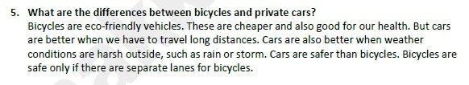

1. **Describe a place you visited that has been affected by pollution.**

**The pollution is the biggest problem which is increasing at an alarming rate all over the world. I think there is no place that is in the world, which is pollution-free.**

**Here I am going to talk about a city in Punjab which is very polluted. People are suffering from many health-related problems because of air pollution, water and noise pollution.**

**I went there in January this year. I went there to visit Sikh gurudwara. The place is very famous for a different thing, but Punjabi people go there because tenth Sikh Guru, Guru Gobind Singh was born here. It is the 19th largest city in India. This place was very beautiful and there were many visitors who really enjoyed a lot.**

**Traffic is very high in this city which not only increases air pollution but creates noise pollution also which affect children’s study and health. I saw people clean only their house, shops and put the waste on the road or in the open area, which dramatically increases pollution.**

**There are more than 50 industries some are IT and some manufacturing companies which produce much polluted water. Sometime this polluted water gets mixed with drinking water which affects people’s health and later on a person can get health related problems. I took a sigh of relief when I came back from Punjab because my eyes got infected due to the air pollution. And, suddenly I had consulted a doctor. So, this is the place which is much affected by pollution.**

**1. What kinds of pollution are serious in your country?**

Well, all kinds of pollution like air, water, soil, and noise are serious in my country. However, due to traffic and factories, air pollution is increasing at an alarming rate.

**2. What can individuals do to protect our environment?**

Individuals can contribute in many ways, like they can use eco-friendly things. People can clean their surroundings and plant new trees. They can use a bicycle instead of a car to cover a short distance.

**3. Do you think individuals should be responsible for pollution?**

Yes, they are responsible for pollution. No one realizes their duties toward nature and uses those things which pollute the environment. People should reduce the usage of private vehicles, plastic, and many other things that destroy nature and save the environment.

**4. Why is there a need to involve government in environmental protection?**

There is a need to involve the government in environmental protection because only the government can make the strict rules which people have to follow if they do not do it then they have to pay heftily amount as fine.

1. **Describe a friend/person who is a good leader.**

**Everyone defines leader differently, but according to my perception, a person becomes a leader only when he knows what is the right path, in which ways he/ she help other people to solve their problem and think about other people first instead of thinking about himself.”**

**I know many people who have many leadership qualities such as my class teacher, but here I would like to talk about my classmate Priya. I believe she is an outstanding leader.**

**She is tall and very beautiful. I know her since college days. She is a very confident and straight forward girl. And, also, she is very intelligent in her studies. She gets good grades in her education. She is a regular student in my class. She never feels shy while speaking in front of someone, so that’s why she clears her ideas very smoothly. I vividly remember she never misses even a single competition of debate and presenting the presentation.**

**She is the head of the class in the college. After completed her study, she joined a multinational company at Ahmedabad where she is working as a head developer.**

**Her communication skills are excellent. She attends many meetings at the international level because of her confidence and English. She also does much social work and helps poor people. Especially poor girls who want to pursue their study and She donates money for their education. Now she lives away from me, so we communicate with each other through phone and social sites. So, Priya is the good leader whom I know.**

**1. Who is the head of the family in your culture?**

In my culture, the head of the family is the oldest male member of the family if there is no older male in the house then more former lady is the head of the family.

**2. Are men better at decision making in a family?**

I think gender difference is disappearing now a day, so both are equally capable of decision making.

**3. Do you think that in future there will be more women leaders?**

It is difficult to predict the future. Women are indeed coming up in every field, so it could imagine that there will be more women leaders in the upcoming time.

**4. Should a leader discuss with team members when making decisions?**

Yes, a leader must discuss all the points with the team before making a decision. In that way, a leader gets new ideas about the decision.

1. **Describe a dinner you really enjoyed.**

**I attend many parties where I had dinner and enjoyed a lot. Some dinners I enjoyed because of the quality of food, some I enjoyed because of thew occasion and some I enjoyed because of the good company. Here I would like to talk about a special dinner which I enjoyed a lot. My family arranged it on my birthday. I enjoyed not only the food was very delicious, but I spend a good time with my friends and family also because I rarely get chance to spend some good time with my family.**

**Last month on my birthday my family arrange dinner for me. Whole food was prepared at home by my mother and some friends also help her in cooking. They made all my favourite dishes such as Mexican rice or pulao. The dinner arranged on the terrace in the open air and surrounded by the plants.**

**My friends decorate the terrace with flowers, balloons and lights. Dinner starts with paneer tikkas and cheese balls which is one of my favourite snacks. Everyone knows I love Mexican food, that’s why they cooked it for me. After that I ate Pulao and Mexican rice after starter, especially I loved Mexican rice which was cooked by my dearest mom. Honestly speaking my mother has excellent culinary skills. At the end, I ate chocolate cake which my best friend cooked for me and which was really very delicious. After dinner we played music and danced. This birthday will be memorable for me.**

**Everyone gave me a special gift and wished me a happy birthday. So that was the dinner which I enjoyed a lot with my family and friends.**

**1. Why do people like to have special food on special occasions?**

People like to have exceptional food on special days because they want to make those occasions memorable, and they also enjoy that particular time with family and friends.

**2.** **What is the difference between eating at home and eating out on special occasions?**

There is much difference. When we are eating at home, the hosts spend their whole time in the kitchen and has less time to spend with friends and relatives, but it did not happen when we are eating out on special occasion because people arrange some  
organizers who organize the event and there is no pressure on the host. So, he/she can easily spend time with friends and family.

**3. What national identity can be seen in a nation’s cuisine?**

The food reflects its cultural traditions. For example, India is a diverse country, and culture varies from state to state. Every state follows a different tradition and makes food according to it.

**4. Why do global leaders like to gather around for dinner?**

When leaders want to discuss the critical matters informally, they get together for dinner because it reflects relations between countries.

1. **Describe a large company that you are interested in.**

**There are many large companies such as Amazon, Reliance Industries, Flipkart, Google and so on.**

**Everyone dreams to work in such an environment which does not promote healthy competition but also includes AMIABLE employees.**

**Even though I always wanted to build my own company, now I have changed my mind and want to gain some relevant experience.**

**I came across a RENOWNED company which LURED me because of its perks. It is Infosys.**

**Yes, I really want to work in Infosys Company. Actually, a few months ago, my friend was looking for a company to work as an intern.**

**Then he ASKED FOR A FAVOR from me. I googled different companies that might be of interest.**

**Then I thought I should google about Infosys itself.**

**When I searched about Infosys on google then I got to know that it has more than almost 2 lakh employees working for it. Moreover, Infosys is India's leading IT sector company.**

**Its PERKS to the employees ASTONISHED me. I have always seen many people who adopt a SEDENTARY LIFESTYLE while working whereas Infosys employees do not face such issues because this company provides different packages.**

**Apart from this, there are many organizations that do not care about employees' well-being and people always have to overwork.**

**However, in Infosys, employees can head over to the on-site massage therapists.**

**It does not only save money but also REFRAIN people from the stress of overwork.**

**I consider it as CHERRY ON THE CAKE. In addition to this, they have a 25%-time policy.**

**This policy goes by the ratio of 75% work and 25% play. These benefits really encouraged me to work hard and achieve my goal of working in the 'Infosys' company.**

**I feel this is a WINWIN SITUATION because happy employees show more PRODUCTIVE in the work.**

**I would consider myself a fortune if I get a chance to work there.**

**1. What are the differences between a big company and a small company?**

Big companies work at the international level, so it is a status symbol to work in these companies. The second advantage is that the company offers an excellent salary to its employees and provides extra facilities like traveling and health insurance.  
Small companies: there are many small-scale businesses which is only limited in a single city or state. These companies offer small package and do not provide extra facilities.

**2. Are there many big companies in your country?**

Yes, there are many big companies in my country. Like Reliance, Tata. Many international companies also open their branches in India.

**3. What are the good things about working for a big company?**

Same as answer 1

**4. How can a small company grow big?**

There are many methods through which a small company becomes a big one. First is that the company can employ skilled and professional workers. Second is the right market strategies very helpful in growing business.

**5. Should big companies donate more to charities?**

Yes, they should donate more to NGOs. Ordinary people can provide small help like food and clothes, but only big firms can provide financial support to charities through which poor children get proper education and life.

**6. Should big companies be punished more seriously if they break the law?**

No, I think the law is equal for all, so it does not matter how big or small the company is.

**7. Are there any big companies in your hometown?**

Yes of course, there are many big companies in my hometown such as Panth TechnoLab, it’s an it company.

**8. Is it difficult to get a promotion in a large company?**

Yes, it is tough to get promotions in a big company because many skilled and professional people work there, so it is tough to beat them. Moreover, it is possible only when a person works very hard and has the right patient level.

1. **Talk about something you enjoyed doing in a group.**

**People have different capabilities. When they work in a group, they combine their skills and knowledge, and then they can handle bigger and difficult tasks also. In fact, there are many works which an individual alone cannot do. For such works, team-work is better.**

**I like to work in teams. In a team, I can learn from other team members. Team members join together with same goal, and they combine their skills, knowledge and motivation to achieve the goal.**

**Last year, our government appealed to all the people to come forward and help in cleaning the City. There was a wastage dumping zone in the city which was spreading infections.  We all wanted to convert that place into a park because that place was just in the centre of the city and park would benefit all the people.**

**So, I joined hands with others. We were a group of 50 members who agreed to give service to the community. Jagdish Patel mayor of our city was acting as head of the group and giving direction to the members. We all were happy. Members were motivating and helping each other. I along with other volunteers cleared the garbage from that place and transported it to other distant location. Then the ground was levelled with layers of new soil. Luckily, some rich people had donated cement, bricks, which were used to build boundary of park with the help of Volunteer masons. Then group members brought full grown trees and saplings and planted them inside the park in beautifully designed lanes. I myself planted 15 “Neem” trees in the park.**

**All group members were happy by contributing to this project. I enjoyed this community work with my friends in the group. I felt a great sense of satisfaction and peace at my heart.**

**This was a big project but when a group took the responsibility, it became easier.**

**So, this was something that I enjoyed doing in a group.**

**1. What kinds of quality does a leader need?**  
Many qualities that a leader need. For example. a leader must have excellent communication skills. A leader should be very punctual and have good patience.

**2. What are the reasons for the failure of teamwork?**  
Teamwork fails because of poor coordination and lack of adjustment and on the top of its unskilled leader.

**3. Do children need to know more about teamwork?**  
A. yes. children should know about teamwork because it is very beneficial for their future. Teamwork skill helps them to make proper coordination which makes the team more robust.

**4. Is cooperation more important than the competition?**  
According to my perception. both are equally important. We need cooperation during teamwork which make the team strong and help us to compete with other people.

**5. Which one do you think is more important: individual development or team goals?**  
A. Both are equally important. Whenever a person works individually, he/she gets a chance to rise individually, which increase his/her confidence. On the other hand, teamwork is also essential because a person cannot do everything alone. So, through teamwork, a person comes to know how to adjust.

**6**. **Do you think it is a good thing to have disagreement within a team?**

Yes definitely. It is good to have disagreement within the team, because otherwise there is no fun working in a team. You have to learn to accept the good points of the other members and you also have to learn to put forth your view in a team.

**7. How to become a good member of the team in the workplace?**  
A person become a good member of a team only when if he/she respect and praise other team members work and do his/her job with full dedication. hard work and with honesty.

1. **Describe a film you watched or Describe a film that made you think a lot.**

**There are some movies that we watch and forget while some others have an everlasting effect on our lives. Well, there are a variety of movies and TV shows that are broadcasting on Television through many channels.**

**Some shows or films are funny which make you laugh but some are another type of shows or movies such as motivational and educational.**

**But here I would like to talk about a film named “Phir Hera Pheri ” which made me laugh a lot.**

**Even though it was released in 2002, last Sunday I got a chance to watch this movie on television.**

**Actually, last Sunday, neither my internet connection was working nor I had any important things to do. So, out of boredom, I decided to watch this movie on television with my family.**

**Coming to the movie, it has 3 main characters namely Raju, Shyam and babu bhaiya.**

**They all were already rich but wanted to become more reach so they invested 50 crore rupees in a company called Anuradha chit fund.**

**That investment company claimed to double their investment in 21 days.**

**But, after 21 days when they went to their office, there was no such company available and they realized that they have become a victim of fraud.**

**The story evolves around these three, who, because of the greed of doubling their money get trapped and land in serious troubles.**

**Apart from this, it is an epic with numerous rib-tickling moments that make one laugh until his side’s aches.**

**Moreover, the comic timing and dialogue delivery both are astounding.**

**The climax of this movie is hilarious and I vividly remember we all had a belly laugh after watching it.**

**Watching this movie with my family gives me immense pleasure and it rejuvenates me. And also, I got a good chance to watch this movie with my family because apart from this I’m always busy with my stuff.**

**It is the best comedy movie of the Bollywood till date. I think everyone should watch it once.**

**1. What sorts of movies are popular in India?**

Well, India is A diverse country. All genres of films are popular in India. People love action, comedy, drama, thriller, romance, and many other films.

**2. Do different age groups like the same kinds of movies?**

No, I don’t think so. Folks from different age classes normally have a different decision in terms of the sorts of films they like. By way of example, the older generation may prefer movies related to political and social issues, and kids may prefer comedy and action movies. I believe the preference for the type of movies people like, changes with age.

**3. What kinds of movies do young people particularly like?**

Young people like to watch films based on fact or real-life incidents. Superhero and science fiction films are also quite popular with kids. Other popular genres enjoyed by the young generation are comedy, romance, horror, and action.

**4. Do fewer people choose to watch films in cinemas than people did before?**

No, I do not think so. These days more people choose to watch films In cinemas when compared with the past. People are leading a very busy and hectic life and visiting cinemas to watch movies is a popular way that people opt for entertainment and for spending time with family members and friends.

**5. What are other ways to watch movies now?**

Some other ways to watch films are on TV, through the online streaming Websites and programs like Netflix, Hotstar, Amazon Prime Video, etc. and through DVDs, which, however, is becoming less popular.

**6. What’s the difference between American films and films from the nation?**

There are some differences between Indian and American movies. The content of the script is among them. It’s More closely about the respective cultures of these nations. Language is 1 stage of difference. Indian movies are produced in Hindi, English, or a lot of different languages, depending on the region they’re created in. Another point of difference is that the technology is accessible and used in movies, especially for images, like in animation and for special results. Indian movies still should catch up on that and haven’t reached the amount of finesse in this field as American movies have.

**7. What do you think about violent films?**

I think if the violence showed is not too detailed or graphic, then It is a great form of entertainment, especially for action movies. But when the violence is explicit and graphic, then it might lead to consequences like more aggressive and violent behaviour, especially among the youth and a sense of fear, or it may traumatize a few people.

**8. Why do you think movies need computer techniques?**

The usage if pc systems are vital for cartoon movies. However, even at the other movies, it is now important, as it might help incorporate an element of excitement and action by showing some stunts that cannot be performed by someone. Therefore, also eliminating any danger to the stuntmen’s life or reduces the odds of accidents or accidents.

**9. Do you believe cinemas will disappear in the future?**

No, certainly not. I Believe the prevalence of cinemas will not fade In the future. People will continue to visit cinemas for the adventure they offer and for the opportunity to spend quality time with their friends or family. The technology accessible has also made the cinematic experience better not only in terms of the content and images but also in the viewing experience for your viewers. By way of example, the 4D technology has made it possible for viewers to feel they are a part of the film. I believe more such modifications will be witnessed in the future.

**10. Can you think (watching) films have (has) educational benefits?**

Yes, it certainly does. Films teach us a lot of items, like Culture, history, language, societal and moral values, and about our responsibilities and duties to society. There are lots of documentary films that are based on details and real-life adventures, which also teach us a lot about various subjects and areas.

**11. Do men and women like to watch exactly the same types of films?**

Yes, I believe the selection of films is very personal and not based on gender. Some individuals may feel that since women are more psychological, they enjoy romantic movies more while men prefer seeing action-based films. However, it isn’t accurate, as we can see an almost equal proportion of females and males in a cinema hall, for any specific genre of films.

**12. In what ways are documentary films and movies just for entertainment different?**

The primary point of difference between a documentary and amusement Movie is that the former is always based on reality and facts, while the latter may or might not be reality-based. Entertainment films are, for the most part, based on a fiction-based script or story. Another difference could be that the funding required for a documentary film is lower than that of a fun one. Actors are needed for an entertainment film, while in a documentary, mostly non-actors share their experiences or understanding. There may not be a demand for a whole film crew such as a makeup artist, cameraman, Lightman, etc. for a documentary film. Many men and women use video cameras these days, only their telephones to make a documentary.

**13. Why do you believe documentary films are not as popular?**

The main Reason documentaries are not so popular. Is that they are not usually entertaining. They usually deal with severe Topics like social problems, wars, etc. and those Based on details, like about the animal species, distant areas, etc.

1. **Talk about a new public building/place, which you would like to visit.**

**I like to explore new places and there is one place which I have been planning to visit for quite some time now. I would like to visit SRK Collections centre which is nearby my house. Also, there are many shops inside such as clothes, shoes and groceries shop. I got really interested to visit centre after one of my friends visited there and told me all about it and its main attraction points and advantages for a shopper like me.**

**The centre was opened only two months back and has already become a popular place among local residents to hang out. The biggest advantage of this is its central location which makes it easily accessible to all the people of the city. But for me, the main attraction is the options that it would provide me. I am not a brand conscious person but I don’t mind wearing branded clothes either.**

**I am not willing to pay exorbitant price just to put a brand name on my clothes. For me, there should be a balance between the appearance of clothing and the price I pay for it. And that is why I would love to visit this place because it would give me that perfect balance. As my friend told me that all the major clothing brands have their outlets.**

**Every time he visited these outlets, he could easily find some offers running which allowed him to make good purchases within his purchasing power. He told me that I might not get the best of the lot but I would definitely get decent clothes at reasonable prices. He has already gathered a nice collection of clothes, shoes and some accessories, all thanks to the centre.**

**There is one more reason why I would like to visit this shop and that is beside it, food court is also there. So, one can eat their favourite dishes. My friend simply loves the place for the options it has. We can choose from all the popular cuisines including Indian, Continental, Chinese, Mexican, Mughlai, Italian and many more. From the description of my friend, this place sounds really interesting and refreshing and I am sure I will soon give it a visit.**

**1. What measures should be taken to deal with damage to public facilities?**  
The government should use two methods. First, appoint people for the maintenance of these facilities and should fix a small amount for these facilities. Another technique is there are some areas where the government cannot appoint people, so in these places to install CCTV cameras.

**2. What is the difference between the old facilities and new facilities?**  
Parks and libraries were famous facilities which people used to spend their free time. On the other hand, nowadays people use new facilities like gyms and leisure places which are based on technology.

**3. What are the facilities do young people and older adults like in your country?**  
Well, older adults like to spend time in the library and parks with his/her friends, but young people want to use the gym and leisure centres.

**4. What is the difference between facilities in the countryside and the ones in the cities?**  
Education and health facilities are available in both places, but entertainment facilities and shopping malls are only available in cities.

1. **Describe your favourite clothes**

**Everyone loves fashion nowadays. Even I also like to try new outfits every day and especially on the functions or special occasions.**

**I have got a huge collection of different dresses and suits in my cupboard.**

**Interestingly, I love to go shopping and when I free from my studies and work at that time I prefer to go shopping with my friends and my mother. I have a lot of clothes according to fashion. I also like stylish clothes to wear on special occasions. But here I would like to talk about my favourite Clothes that I love to wear the most.**

**Well, this is a Roadster Sweatshirt. On the sweatshirt, the Roadster logo is printed the left side off the sweatshirt. This was gifted by my friends on my last birthday.**

**Apart from that, the colour of the sweatshirt is black and it looks awesome. I usually wear this sweatshirt with blue denim jeans and black high waist jeans. A black sweatshirt with denim jeans perfect Combination for a man.**

**After that, this is very comfortable and I love this combination. I usually wear this sweatshirt during the winter because the stuff of this sweatshirt is very amazing. Every product such as Jeans, T-shirt, Jackets from Roadster company are very comfortable. And I like to wear clothes which are very comfortable for me.**

**Moreover, this is water and windproof as well as it is very light weighted. This sweatshirt consists of two layers. First is a soft inner layer and second is a tough outer Shell. The inner layer is made of spun fleece which helps the body to warm.**

**Furthermore, the most interesting thing is this sweatshirt protects me from winter. Basically, I wear sweatshirts in winter season only. This is a full sleeved sweatshirt and also it has a cap.**

**At last, not least, my friend bought this jacket from the mall which is which is located at far distance from my home. I love this piece of cloth because it is gifted by close friend.**

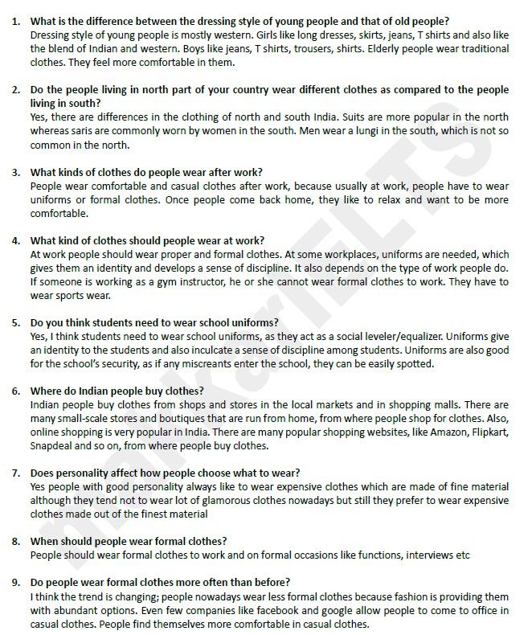

1. **Describe an experience you had as a member of a team**

**People have different capabilities. When they work in a team, they combine their skills and knowledge, and then they can handle bigger and difficult tasks also. In fact, there are many works which an individual alone cannot do. For such works, team-work is better.**

**I like to work in teams. In a team, I can learn from other team members. Team members join together with same goal, and they combine their skills, knowledge and motivation to achieve the goal.**

**Last year, our government appealed to all the people to come forward and help in cleaning the City. There was a wastage dumping zone in the city which was spreading infections to the people who were living nearby. We all wanted to convert that place into a park because that place was just in the centre of the city and park would benefit all the people, especially elders.**

**So, I joined hands with others. We were a group of 50 members who agreed to give service to the community. Jagdish Patel mayor of our city was acting as head of the group and giving direction to the members. We all were happy. Members were motivating and helping each other. I along with other volunteers cleared the garbage from that place and transported it to other distant location. Then the ground was levelled with layers of new soil. Luckily, some rich people had donated cement, bricks, which were used to build boundary of park with the help of Volunteer masons. Then group members brought full grown trees and saplings and planted them inside the park in beautifully designed lanes. I myself planted 15 “Neem” trees in the park.**

**All group members were happy by contributing to this project. I enjoyed this community work with my friends in the group. I felt a great sense of satisfaction and peace at my heart.**

**This was a big project but when a group took the responsibility, it became easier.**

**So, this was something that I enjoyed doing in a group.**

1. **Would you like to work alone or work with a partner?**

I enjoy working independently since I kind of hate being dependent upon other people. However, it also depends upon the team members. If I have a Fantastic rapport with all the group members, I find it quite enjoyable.

**2. What type of people are good to use?**

The most important quality I try to look for in team members would be sincerity. I mean sincerity with work. I’ve sadly worked with a lot of Individuals who procrastinate endlessly, and I really dislike working with such people.

**3. Do you enjoy team work or group studying?**

Yes, group learning/work is certainly enjoyable because it involves sharing of ideas and discussions. Working/Studying alone sometimes can be very boring. But occasionally it is also irritating especially if some of the group members like talking a lot because then I get distracted.

**4. What are the benefits of studying alone?**

The largest benefit of studying alone definitely is that we can concentrate better. So, it’s more effective to study independently. Another advantage of studying alone is the flexibility it What I mean is that we can study whenever or where we need, and we could study at our speed.

**5. What can children learn through teamwork?**

The most important benefit I feel is children learn how to cooperate and work alongside others. This is really valuable in adult life when people have to work together on projects.

**6. What are the disadvantages of working in a group?**

I think, firstly, functioning in a group can be really inefficient because We Must work at common set speed. Secondly, it occasionally leads to sense of jealousy in the event other members aren’t very sincere in their work and we’re dependent upon them to finish their job.

**7. Is it great to have differences within a group?**

Nicely both no and yes. Yes, because staff differences make sure more time is spent deliberating on issues, so there are less odds of mistakes. No, because having differences means it slows things down.

**8. What are key skills and abilities necessary to be prosperous in a team?**

I think that the major skill required to achieve success is the ability to work well with others. People should be accommodating, but also not so accommodating they shed their voice. What I mean is they should be open to ideas of others but also express their thoughts and reservations about ideas of others.

1. **Describe a goal that you achieved, which was set by yourself.**

**I don’t think I have a stronger willpower and many times I have set goals but failed to achieve them.**

**I have always been interested in setting goals and made more efforts to achieve these goals because, in this way, I save my time and energy as I planned every task before doing it. However, I**[would](https://ieltsfever.org/tag/would/)**like to talk about a goal that I set by myself that was my graduation marks.**

**when I was in college in diploma engineering second year I suffered from illness, I was having a kind of fever and I was not able to concentrate on my studies during this condition, I really want to pay attention towards my studies but due to my health I was not able to attend college or my regular classes. I was very tensed and stressed thinking that how I will manage my pending studies. And after it was the day for my final exam results. I couldn’t get favourable marks so then I moved in final year I set target that was 75perent marks above which I wanted to obtain anyhow because the performance of previous year affected my overall graduation performance in my college life that was very**[**important**](https://ieltsfever.org/category/important/)**in future for my higher**[**study**](https://ieltsfever.org/tag/study/)**or in getting a good job.**

**I made my study timetable, and I was following that regularly and also, I did lots of preparation to achieve my goal. During exam time, I performed well according to my training. After a few months, when my result was declared, I felt jubilant as I got 77percent marks. Apart from this, I got the second position in the overall degree.**

**I felt so excited because that marks were valuable for me, and I got my goal set by myself. Doing this made me really confident and I started going out and meeting my friends again.**

1. **Do people need to write down targets or just memorize them?**

I live to write down my objectives. It just offers that additional motivation because of a weak moment or when we are having a terrible day, and we feel like giving up.

**2. Do Indian people usually set goals**?

Yes, many Indian people do. I recall on 1st of January, many of my buddies and I share our new year goals and resolutions.

**3. Should parents set targets for children?**

I believe parents should inspire children to maintain aims, but I don’t Think parents should themselves keep their goals. Because I think if children don’t maintain the aims, they won’t possess exactly the same degree of motivation to fulfil them.

**4. When do young men and women begin setting targets for themselves?**

I think there’s no fixed age. It all depends upon the person’s Maturity and degree of responsibility. Some people begin keeping goals at a very early age like at ten or twelve, while others begin keeping goals after attaining adulthood. Goal setting is much more about self-fulfilment and creating oneself better and that understanding to make oneself better sometimes come early and sometimes late.

**5. What are the sorts of goals that are unrealistic?**

I think goals which are in tune with an Individual’s Personality are realistic. I mean should I choose to do something which would need me to make a radical shift in my personality, I wouldn’t be able to achieve it. So that would be unrealistic for me.

**6. Do young people and old individuals have different sorts of goals? What are they?**

I think both no and yes. Are more about accomplishing something in existence, while targets for older men and women are about helping their young achieve their aims in life. No, because sometimes targets can be similar also, for example, I see both young and old attempting to shed weight and look smart at the gyms.

**7. What is more fulfilling working towards a goal or achieving it?**

I think both are fulfilling in their own sense. Working Towards a goal is all about meeting and overcoming challenges; it is all about failing and becoming back. Ultimately, attaining a target brings a sense and that efforts did make a difference. But if we did not struggle to achieve something, neither the work we put in, nor the final goal contributes to fulfilment.

**8. Do you think that it’s important to have realistic objectives?**

I think being Realistic has its advantages and disadvantages. Its advantageous because should the aims are unrealistic, it’s extremely easy to give up and believe that it was not possible in the first place. It’s also detrimental in the sense that we never test our limits. We never try to go beyond. So, I generally set goals to just beyond realistic.